User Guide 57 ePlan Visualisation Enhancement Tool

Purpose of this User Guide
The purpose of this User Guide is to provide information on how to use the ePlan Visualisation Enhancement Tool (VET) to improve the presentation of the Plan PDF generated by SPEAR from the ePlan LandXML file.

Who should read this guide?
Primary audience: Applicant Organisations
For information: Other SPEAR users

Introduction
This tool allows the Victorian ePlan-enabled surveyors to enhance the Plan PDF visualised by SPEAR, using the following main functions:
- adjust labels and arrows
- create enlargement diagrams
- define sheets
- define exaggerations
- adjust title connections.

57.01. How can I access VET?
By accessing the ePlan Portal from SPEAR, open the ePlan Dashboard.
- Click ‘Create New ePlan’ and upload an SCFF or LandXML file. Once the ePlan data is loaded, Click the ‘Visualisation Enhancement Tool (VET)’ icon.
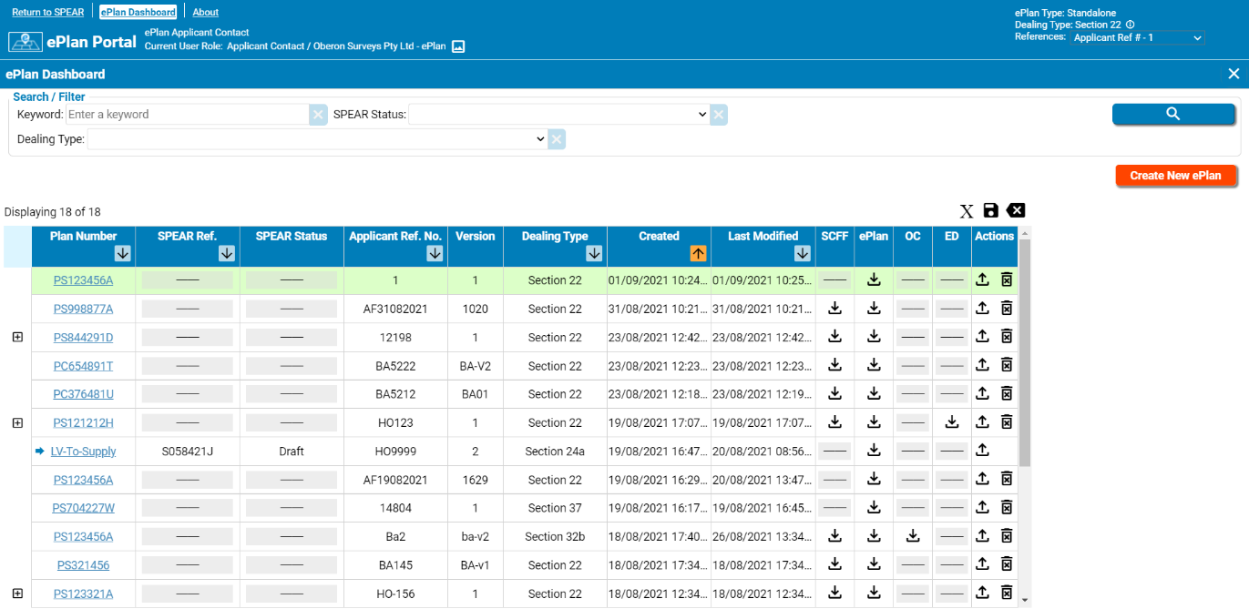

- If you have already uploaded an SCFF or LandXML file to the ePlan Portal, click the corresponding row within the Dashboard to load the ePlan data. Click the ‘Visualisation Enhancement Tool (VET)’ icon.
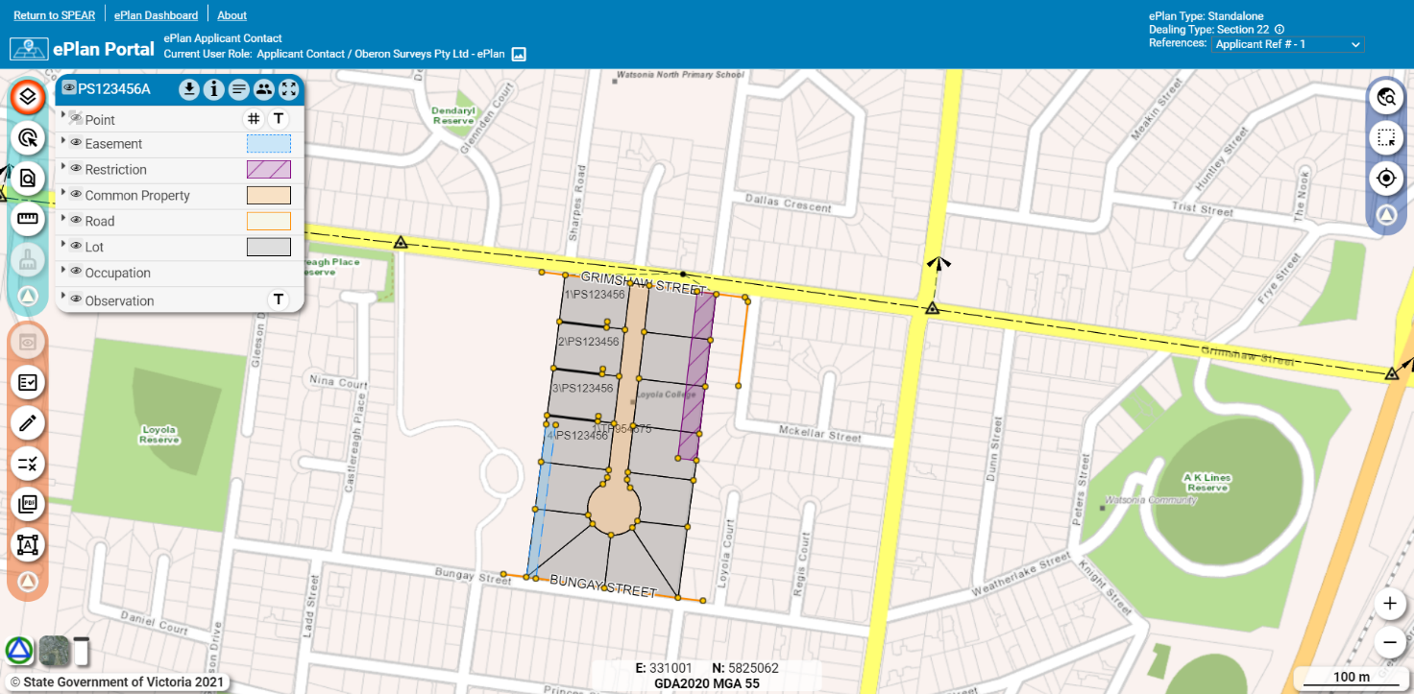

57.02. What are the components of VET?
VET consists of the following components:
- Display Area
- Header
- Toolbar
- Intelligent Key Sheet
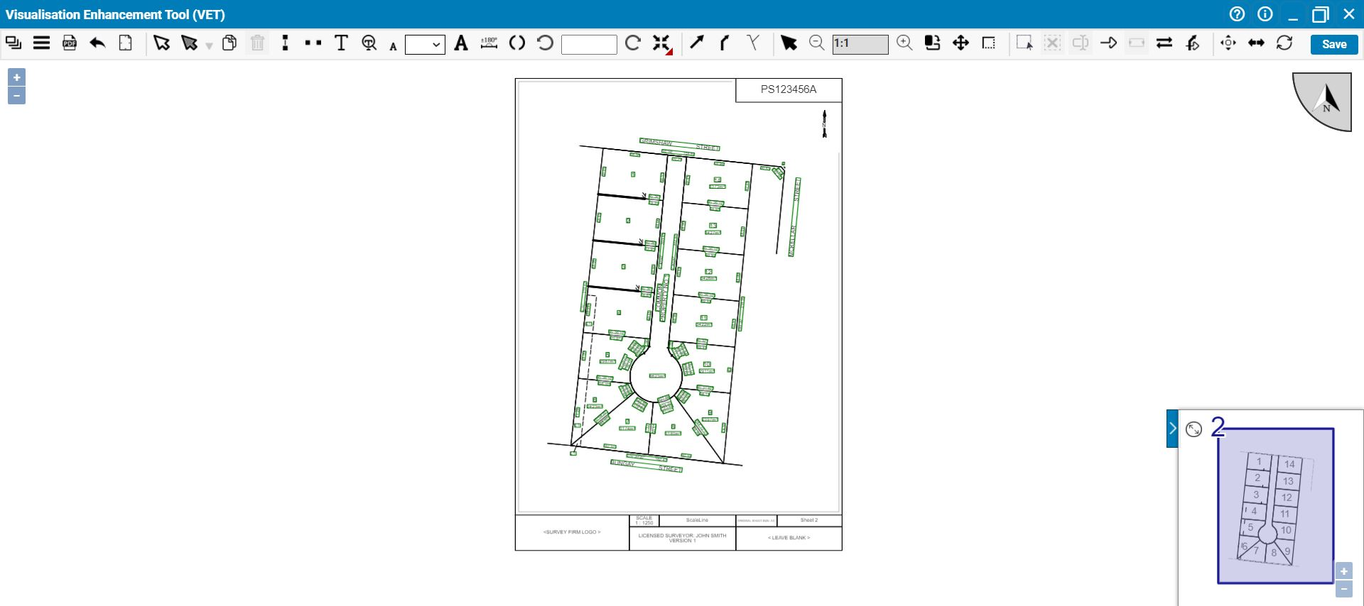
B
C
A
D

A) Display Area
This area shows the diagram part of the plan.
NOTE I: The front sheet and Owners Corporation Schedule are not displayed in VET. Any changes required to those sheets must be applied to the ePlan LandXML file using the ePlan Editor.
NOTE II: On the restriction sheets, only the diagram’s content such as labels and arrows can be enhanced in VET. Restriction text is just displayed and is not editable in VET. Any changes required to the Restriction text must be applied to the ePlan LandXML file using the ePlan Editor.

B) Header
The header provides access to two buttons:

About VET and Handy Hints
Help
Help
The ‘Help ’ button provides access to the current User Guide. Click this button to download the User Guide.
About VET
The ‘About ’ button provides further information about the VET’s functionalities, copyright, credits, handy hints, etc.
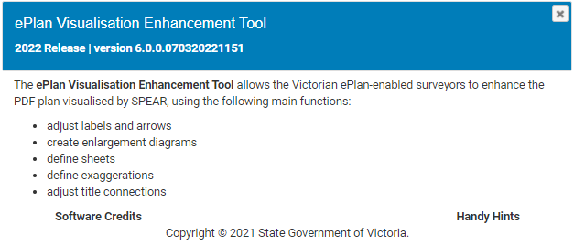

C) Toolbar
The toolbar provides access to all functionalities of VET and has the following components:
F
G
C
E
D
B
A
H
- General Tools | - Enlargement Tools
- Label Tools | - Exaggeration Tool
- Arrow Tools | - Truncation Tool
- Diagram Tools | - Building Return Tool

D) Intelligent Key Sheet
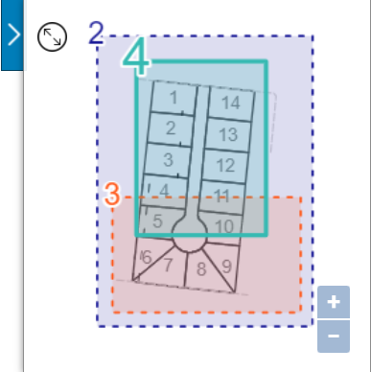
The Intelligent Key Sheet (IKS) tool provides an index to manage all sheets (except restriction and enlargement sheets) created in VET.

57.03. General Tools
The following tools are available in the ‘General Tools’ section:

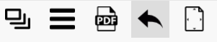
 | Toggle Sheet Pane
 | File Menu
 | Visualise PDF
 | Undo
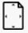 | Fit Full Page to Screen

Toggle Sheet Pane
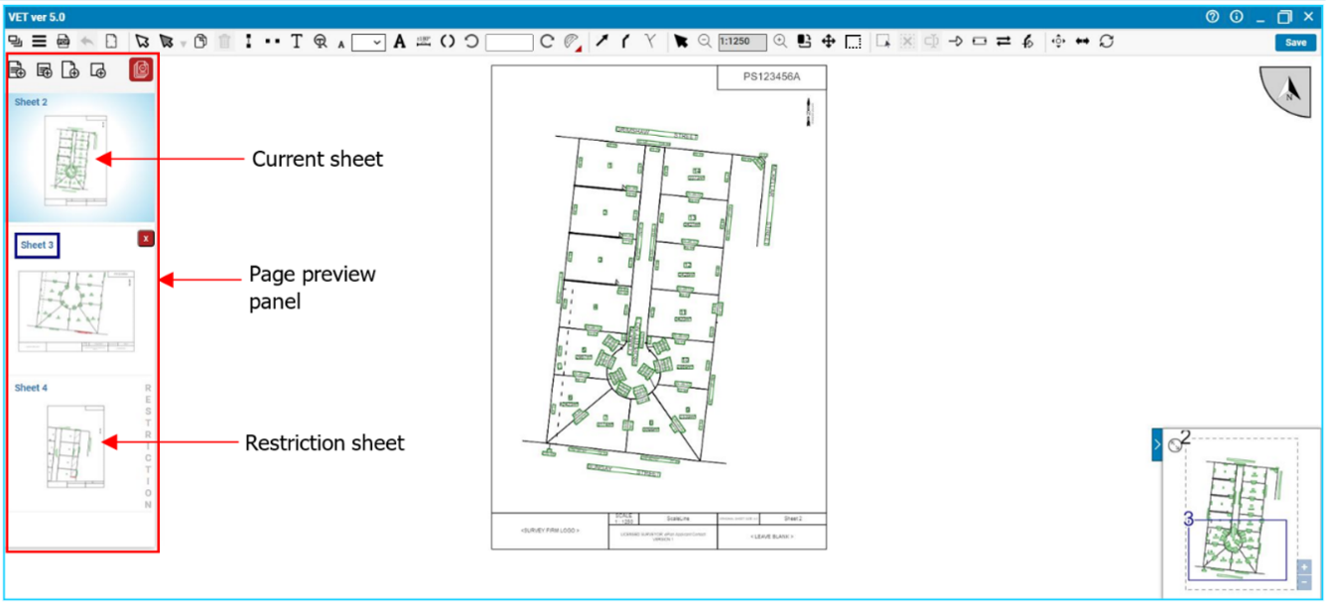
This button opens the page preview panel. This panel provides an overview of all sheets in the plan including the restriction sheets, if applicable. The current sheet is shown as highlighted in the panel. To navigate to another sheet, click on that sheet.

Add sheet
The panel can also be used to add or remove sheets to / from the plan. There are four methods to add a new sheet to the plan:
- Click the ‘Add a new portrait sheet ’ button to add a new portrait sheet including a diagram. By default, this new sheet contains all the line work and labels in the ePlan data.
- Click the ‘Add a new landscape sheet’ button to add a new landscape sheet including a diagram. By default, this new sheet contains all the line work and labels in the ePlan data.
- Click the ‘Add new portrait blank sheet ’ button to add a new portrait blank sheet with no diagram on it. New enlargement diagrams can be added to the portrait blank sheet using the ‘Create Enlargement 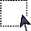’ tool. Portrait blank sheets will have no ‘SCALE’ as each diagram on this type of sheet will have its own scale.
- Click the ‘Add new portrait blank sheet ’ button to add a new landscape blank sheet with no diagram on it. New enlargement diagrams can be added to the landscape blank sheet using the ‘Create Enlargement ’ tool. Landscape blank sheets will have no ‘SCALE’ as each diagram on this type of sheet will have its own scale.
The new sheet will be added to the end of the list as the last sheet. The sheets can be reordered by dragging and repositioning the sheets.
NOTE: If the plan has restriction sheets, the new sheet will be added before the first Restriction sheet. Restriction sheets’ order is controlled by the ePlan Visualisation Service and these sheets cannot be reordered by the user.
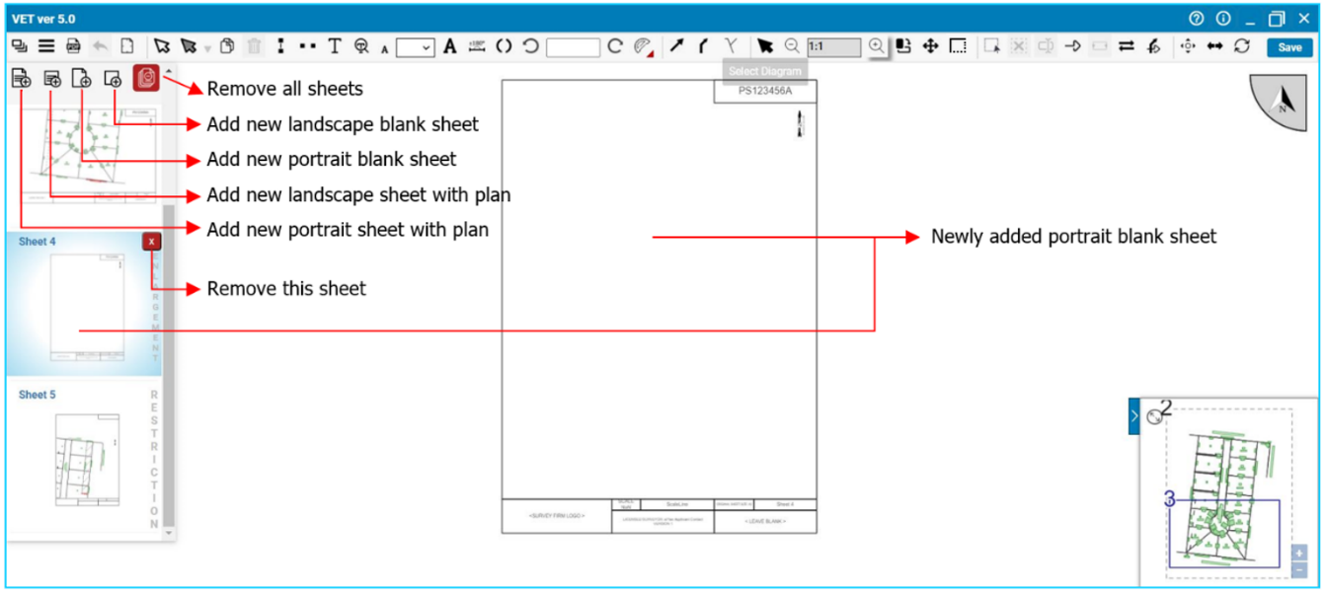

Remove all sheets
To remove all sheets, click the ‘Remove all sheets ’ button. A dialog box will appear to confirm your action. Clicking the ‘Remove’ button will remove all sheets (except the restriction sheets) from the plan. New sheets can be added to the plan using the ‘Add sheet’ function.

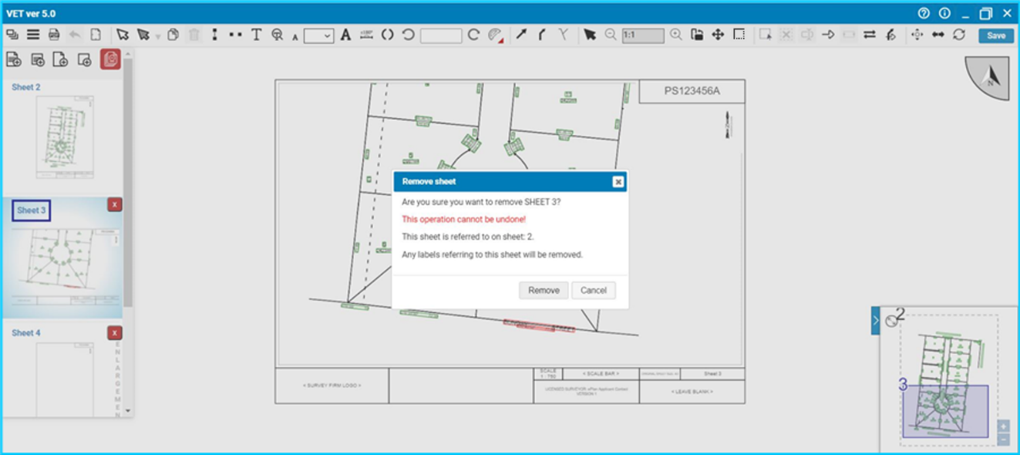
Remove sheet
To remove a sheet, click the ‘Remove this sheet ’ button. A dialog box will appear to confirm your action. If the sheet being removed is referenced on other sheets, the dialog box will notify you about those sheets. Clicking the ‘Remove’ button will remove the sheet from the plan and will also remove any ‘See Sheet’ references to that sheet on other sheets.

File Menu
The File Menu has two buttons:
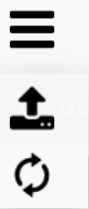 |  | Upload
 |  | Revert to default

Upload
The ‘Upload ’ button allows you to upload an enhanced diagram file from your computer to VET.
VET validates the uploaded enhanced diagram file which should be in JSON format. If your uploaded file is invalid, VET provides you with an error.
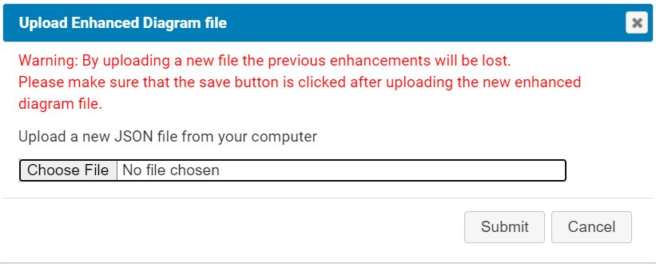

Save
The ‘Save’ button provides you with the option to save the enhanced diagram file to the SPEAR cloud storage.

Revert to default
The ‘Revert to Default ’ button is useful in situations where you have edited the plan but for any reason wish to go back to the default visualisation. This function will replace the current visualisation with a default visualisation created by the ePlan Visualisation Service.
You can click the ‘Revert to Default’ button and change the visualisation to the original visualisation undertaken by SPEAR. Click the ‘Revert to Default’ button and VET shows a dialog box to confirm that you would like to revert to the original visualisation.
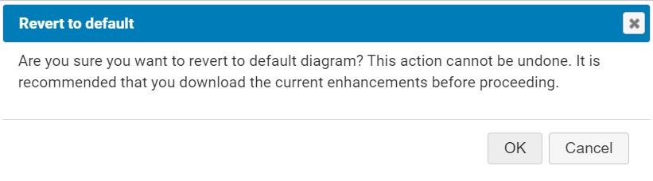

PDF Preview
The ‘Visualise PDF ’ button generates a PDF for the plan as seen in VET.

Undo
The ‘Undo ’ button allows the user to undo their actions. The Undo function is also accessible using the keyboard shortcut ‘Ctrl + Z’.

View Full Page
The ‘View Full Page ’ button zooms the page view to fit an entire sheet in the plan display area.

57.04. Label Tools
The following tools are available in the label tools section:

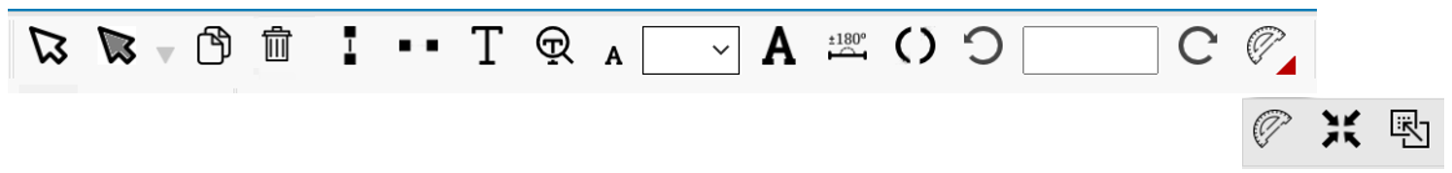
 | Select & Move labels
 | Select parcels
 | Copy
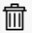 | Remove
 | Wrap/Unwrap Labels
 | Split Labels
 | Show/Hide
 | Show Hidden Labels
 | Decrease Font Size
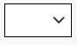 | Specify Font Size
 | Increase Font Size
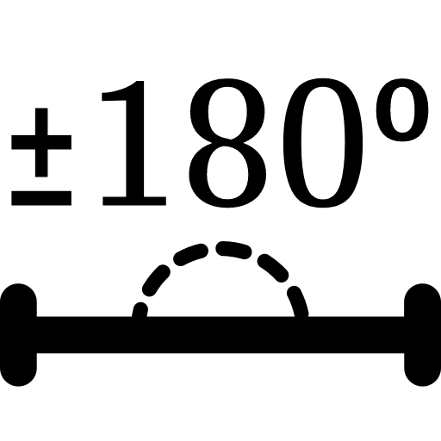 | Add / Subtract 180° to/from bearing
 | Add / Remove Brackets
 | Rotate Counter Clockwise
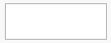 | Rotate to a Value
 | Rotate Clockwise
 | Align ID and Area Labels
 | Centre ID and Area Labels
 | Move Labels Inside Diagram Layout

Select & Move
Click the ‘Select Labels ’ button to activate the label selection mode. The icon will be highlighted to show the activated status. To move a label, select it and then drag the mouse. Moving a bearing and distance label will automatically generate an arrow from the associated line to the label. For the parcel identifier label, an arrow will be automatically generated when the label is moved outside a closed parcel.
Arrows drawn for any label can be edited in VET. Please see the ‘Arrow Tools’ section of this guide for information about editing arrows.
NOTE: When the selected label is a ‘Referencing Label’, using this tool to move the label will only move the label itself. Holding ‘Control Key (Ctrl)’ before you start to move the label will move the corresponding arrow together with the label. When the label is selected, by pressing the ‘Control Key (Ctrl)’ the related arrow will be highlighted.
Selecting multiple labels
To select multiple labels, press ‘Shift’ and click the labels. Pressing ‘Shift’ and clicking a label will select that label in addition to other selected labels. Pressing ‘Shift’ and clicking on a previously selected label will deselect that label from the group. To select all labels in a specific area, press ‘Ctrl’ and drag the mouse. Labels from a single diagram can be selected at the same time, when dragging is started using ‘Ctrl’ and a diagram’s border will get highlighted to determine the active diagram.
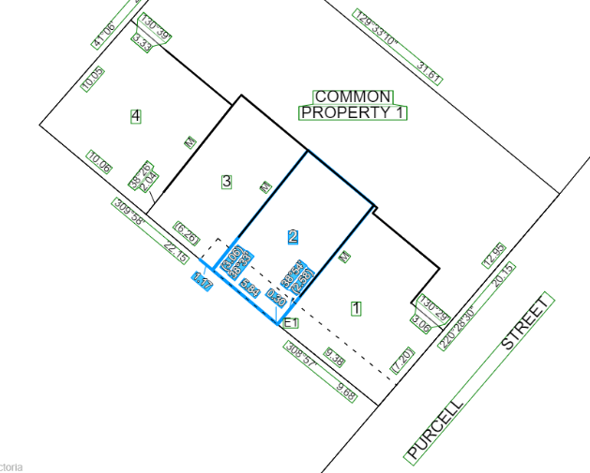
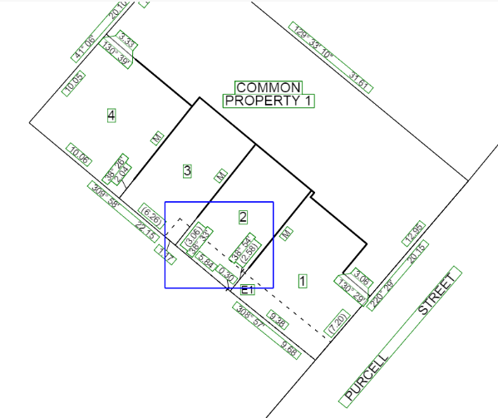
Selecting multiple labels through pressing ‘Ctrl’ and dragging the mouse
Selecting multiple labels through pressing ‘Shift’ and clicking on labels

Select Parcel
The ‘Select Parcel ’ tool can be used to select the labels of a given parcel. Once the tool is activated, clicking on a parcel will select the parcel. Multiple parcels can be selected/deselected by clicking while keeping the ‘Shift’ key pressed. If the point of click contains more than one parcel, a pop-up message will be displayed to select desired parcels.

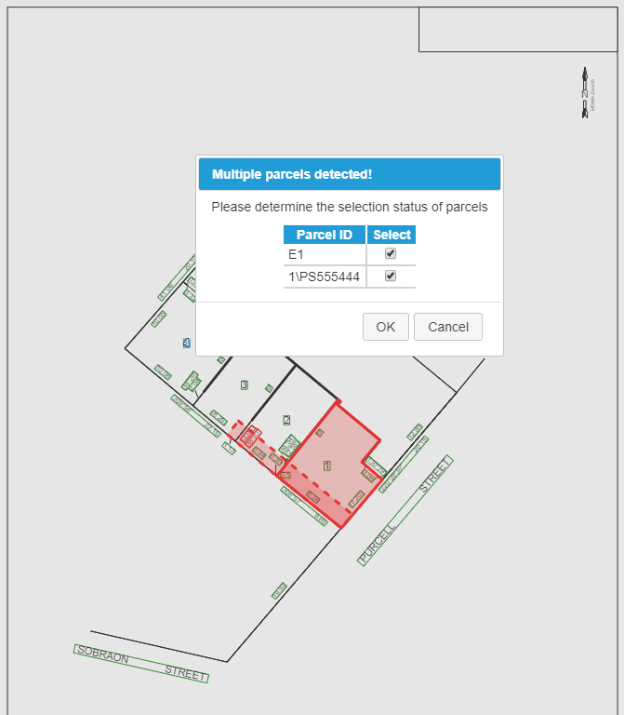
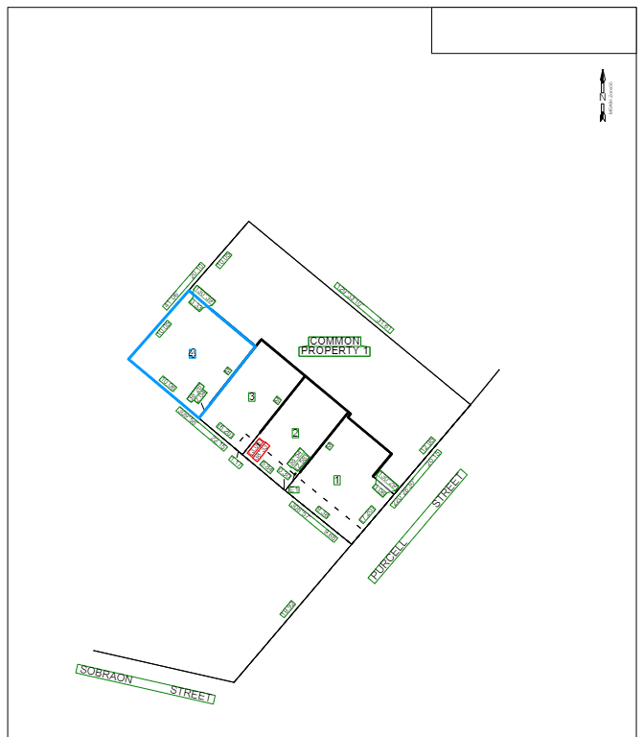
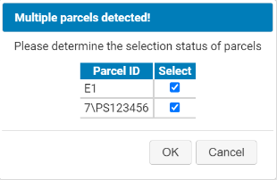
Alternatively, parcels can also be selected by drawing a box pressing the ‘Ctrl’ key and dragging the mouse. Parcels within the same diagram can be selected all at once when dragging is started using ‘Ctrl’ and the diagram border will be highlighted to identify the active diagram.
A parcel is selected using the Select Parcel tool
Pop-up message appears when there are multiple overlapping parcels

Once the parcels are selected, the layers drop-down list can be used to select all the labels of a given type. The list allows the user to select the following types of labels:

Parcel identifier labels

Area labels

Road name labels

(excludes abutting parcel labels)

Bearing and distance labels

(excludes exterior dimension labels)

Connection line and plan feature labels
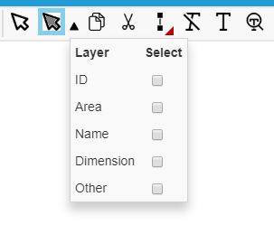

By selecting a checkbox, the labels of that type will get selected for all the selected parcels.
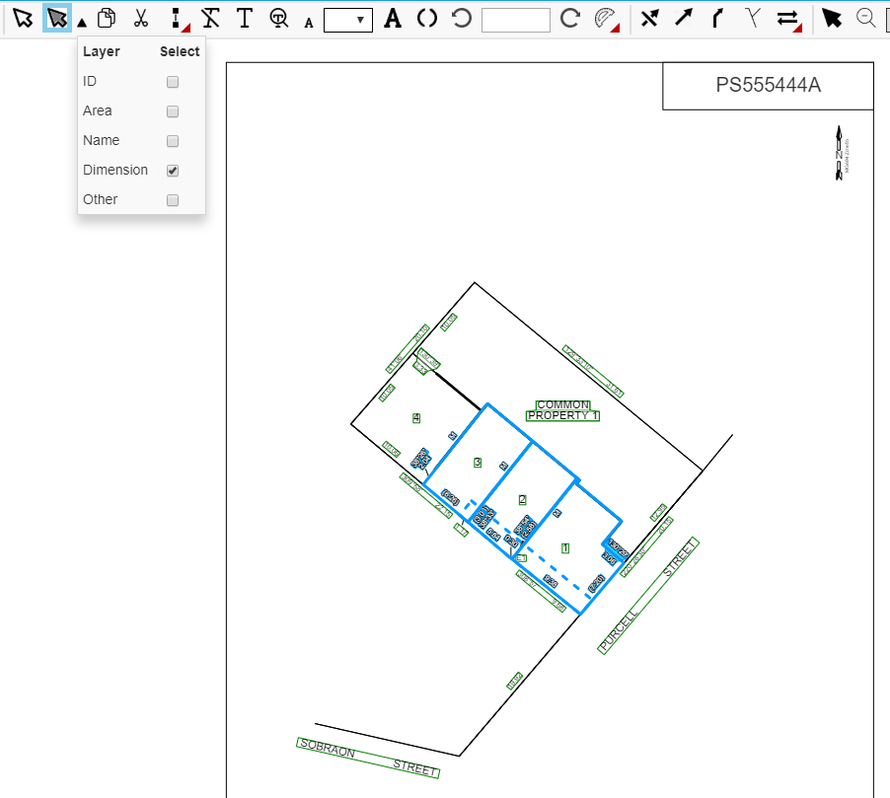
Once the desired labels are selected, the other label tools mentioned in the subsequent sections can be used to edit the labels.

Copy
To create a copy of a label, first select the label and then click the ‘Copy Labels ’ button and then hover the mouse and click on the desired location to create a copy of the selected label.
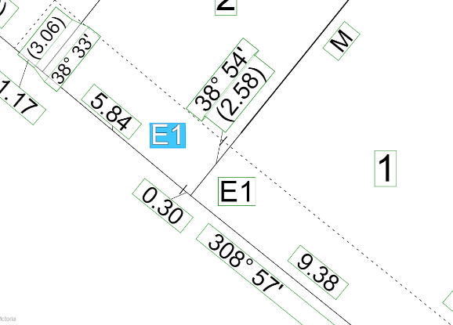
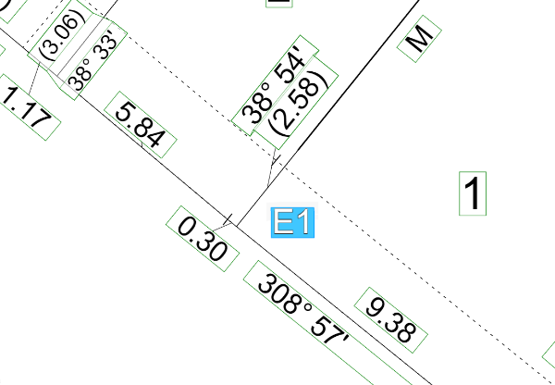

Before the ‘Copy’ tool is used
After the ‘Copy’ tool is used

Remove
To remove a label, select the label and click the ‘Remove’ button. Only labels created using the ‘Copy’ button can be removed. Other labels cannot be removed using this functionality. You can hide such labels using the ‘Hide/Show Labels’ button.

After the ‘Remove’ button is clicked
Before the ‘Remove’ button is clicked

Convert to 2-line Label (Wrap Label)
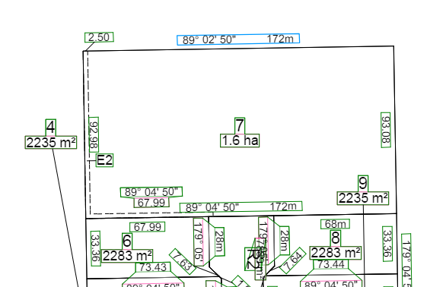
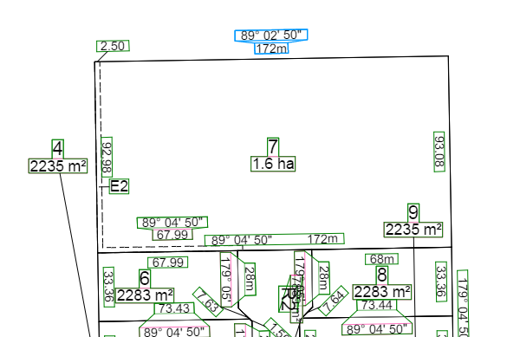
Clicking the ‘Wrap/Unwrap Labels ’ button converts the selected bearing and distance labels from a 1-line label to a 2-line label.
Before the ‘Wrap Label’ button is clicked
After the ‘Wrap Label’ button is clicked

Convert to 1-line Label (Unwrap Label)
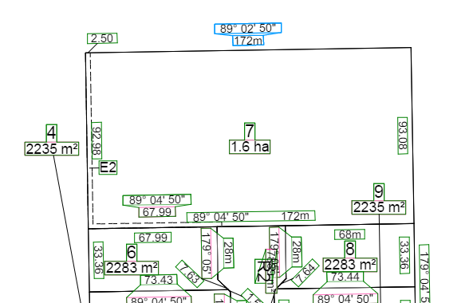
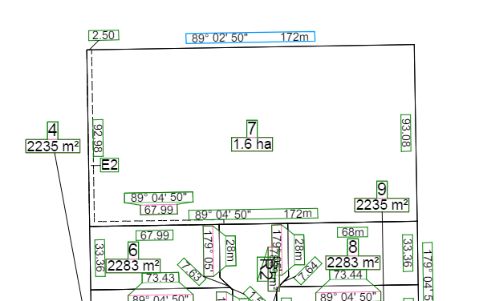
Clicking the ‘Wrap/Unwrap Labels ’ button converts the selected bearing and distance labels from a 2-line label to a 1-line label.
After the ‘Unwrap Label’ button is clicked
Before the ‘Unwrap Label’ button is clicked

Split
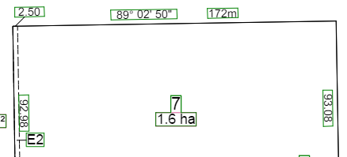
Use the ‘Split ’ button to create two labels from a single label, e.g. bearing and distance label or abutting road label.
After the ‘Split Label’ button is clicked

Before the ‘Split Label’ button is clicked

Hide
Use the ‘Show/Hide Labels ’ button to hide any labels from the diagram.

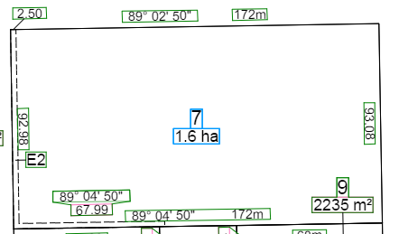
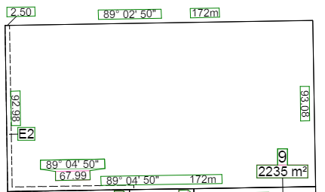
After the ‘‘Show/Hide Labels’ button is clicked

Before the ‘‘Show/Hide Labels’ button is clicked

NOTE: Any label needs to be available in at least one sheet of the plan. If you hide a label from a sheet, make sure that it is displayed in another sheet.

Show Hidden Labels
Use the ‘Show Hidden Labels ’ button to see which labels are currently hidden in the diagram.
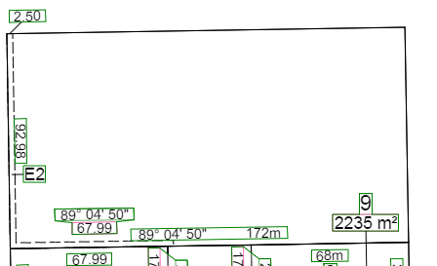
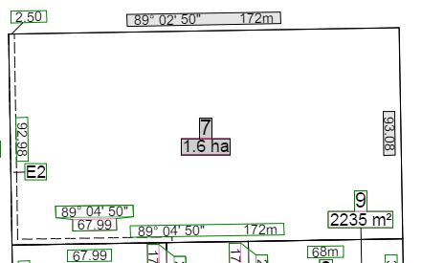
After the ‘Show Hidden Labels’ button is clicked

Before the ‘Show Hidden Labels’ button is clicked

Show
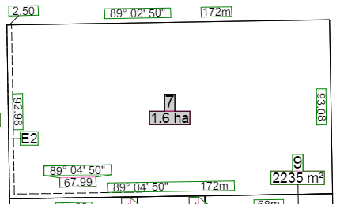
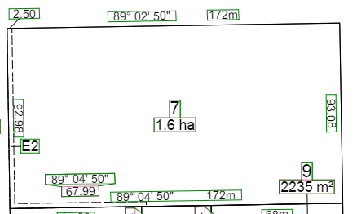
Use the ‘Show/Hide Labels ’ button to display any labels hidden from the diagram.
After ‘Show/Hide Labels’ button is clicked

Before the ‘Show/Hide Labels’ button is clicked (grey background shows this label is hidden in VET)

Decrease / Increase Font Size
Use the ‘Decrease / Increase Font Size ’ buttons to change the size of the text in a label. The minimum font size possible is 2mm and maximum is 8mm.

Add / Subtract 180° to / from bearing
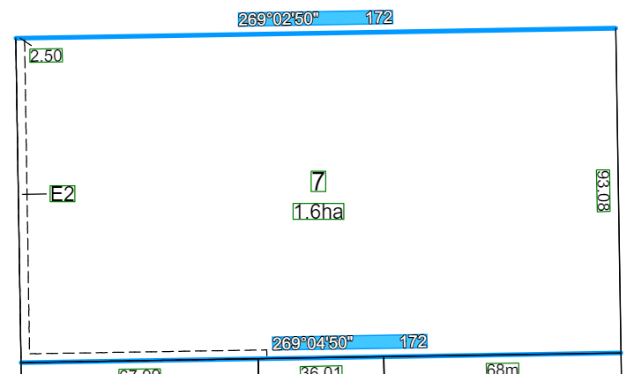
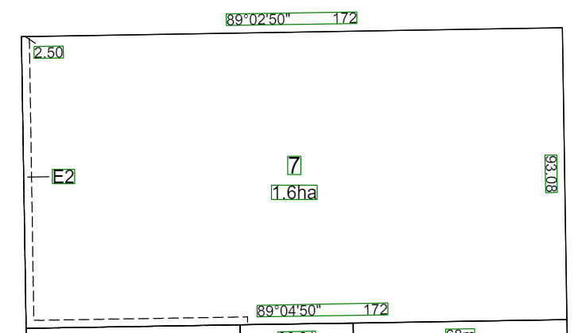
Use the () button to change the bearing value of the selected label by 180°.

Before the using () After using ()

Add / Remove Brackets
Use the ‘Add / Remove Brackets ’ button to add or remove brackets for distances which may run across easements.
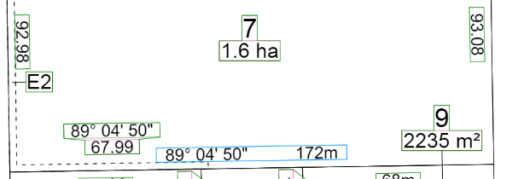
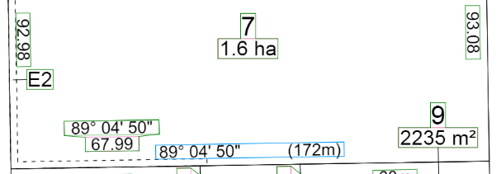
After the ‘Add Brackets’ button is clicked
Before the ‘Add Brackets’ button is clicked

Rotate Counter Clockwise / To a Value / Clockwise
Use the ‘Rotate Counter Clockwise / To a Value / Clockwise ’ functions to rotate a label to a different angle. The buttons and will change the angle by 10 degrees. The text box can be used to set the angle of a label to a specific value. The value should be entered in DD.MMSS format e.g. 89° 01’ 50’ à 89.0150.
NOTE: When the selected label is a ‘Referencing Label’, using the ‘Rotate Counter Clockwise / Clockwise’ tools to rotate the label will only rotate the label itself. Holding ‘Control Key (Ctrl)’ before clicking the tools will rotate the corresponding arrow together with the label. When the label is selected, by pressing the ‘Control Key (Ctrl)’ the related arrow will get highlighted.

Align ID and Area Labels
Use the ‘Align ID and Area Labels ’ function to align the angle of ID and Area labels according to the longest line of related parcels. This tool only affects ID and Area labels for all parcels excluding ‘Easements’.
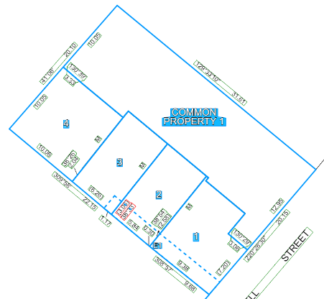
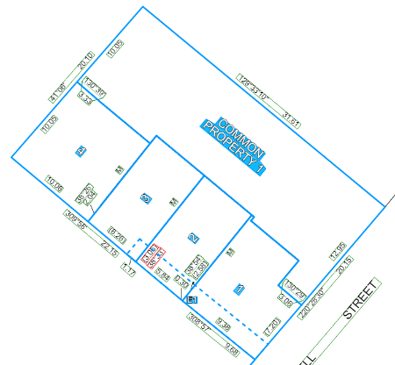

Before the ‘Align ID and Area Labels’ button is clicked After the ‘Align ID and Area Labels’ button is clicked

Centre ID and Area Labels
Use the ‘Centre ID and Area Labels ’ function to move the ID and Area labels to the calculated centre of the parcel (The destination point is normally inside the parcel). If the ID or Area labels are selected individually, each label will be placed on the calculated centre point of the parcel but if the ID and Area labels of a parcel are selected together the ID label will be placed at the top and the Area label will be placed at the bottom of the centre point.

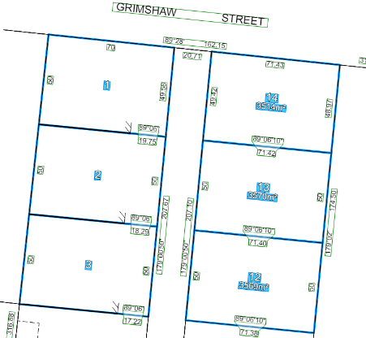
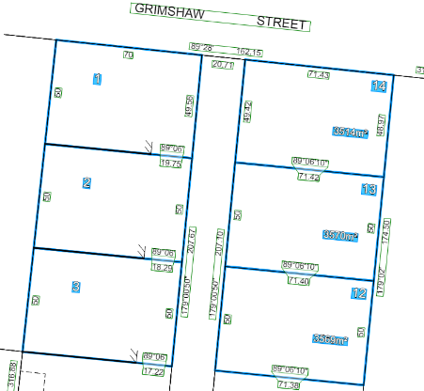

Before the ‘Centre ID and Area Labels’ button is clicked After the ‘Centre ID and Area Labels’ button is clicked
(The tool’s behaviour is different when ID labels
are selected as opposed to when ID
and Area labels are selected together)

Move Labels Inside Diagram Layout
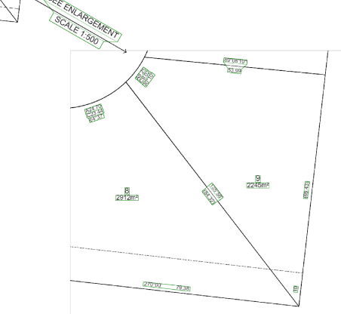
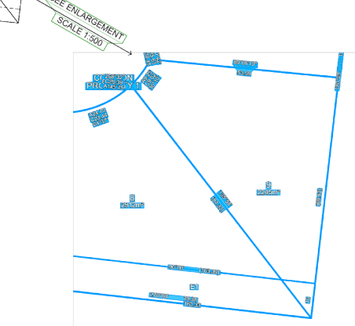
Use the ‘Move Labels Inside Diagram Layout ’ function to move the visible parcels’ labels inside the diagram’s layout so you can find the labels easily. When a diagram (an ‘Enlargement Diagram’) is rescaled or moved, the labels can go out of the diagram’s layout and sometimes, it is hard to find needed labels as they are not reachable. With this tool the labels related to all lines and parcels inside the diagram’s layout will be moved to the centre of the visible part of the lines or parcels. This function affects all diagrams and enlargement diagrams excluding the ‘Main Diagram’ which appears on the first sheet in VET.

Before the ‘Move Labels Inside Diagram Layout’ button is clicked After the ‘Move Labels Inside Diagram Layout’ button is clicked

57.05. Arrow Tools
The following tools are available in the ‘Arrow Tools’ section:
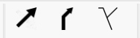
 | Hide/Show Arrows
 | Edit Arrow
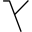 | Snapping On/Off

Hide Arrow
Use the ‘Hide/Show Arrows’ button to hide the arrow for a label. To hide the arrow, select the label and click the ‘Hide Arrow’ button; note the arrows for parcel identifier labels cannot be hidden. This tool can also be used to hide the arrow for Referencing Labels e.g. ‘See Sheet’ labels.
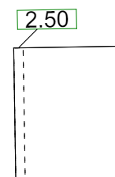
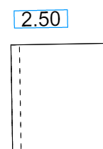

Show Arrow
Use the ‘Hide/Show Arrows’ button to display the arrow of a label that was previously hidden. Select the desired label and click to show the arrow again. This tool can also be used to display the arrow for Referencing Labels e.g. ‘See Sheet’ labels.

Edit Arrow
Use the ‘Edit Arrow ’ button to move the location of the arrow relative to the label. It may also be used to ‘bend’ the arrow. To move the arrow, move the cursor over to one of the end points of the arrow and drag it by that point. To bend the arrow, drag the arrow from any point on the line.

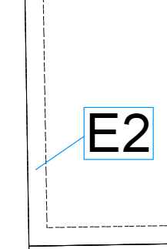
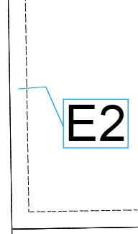
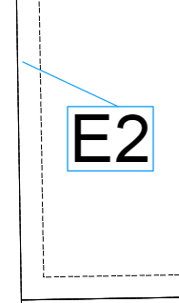
Snapping On/Off
Editing arrow start point
Editing arrow end point
Bending arrow
When this mode is activated by clicking the ‘Snapping On/Off’ button, VET ensures the arrow touches the associated line. However, in a situation where some space is desired between the line and the arrow, this mode can be switched off before moving the arrow.

57.06. Diagram Tools
The following tools are available in the diagram tools section:

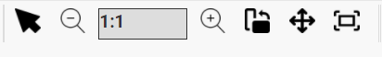
 | Select & Move
 | Scale Down
 | Scale Up
 | Change Page Layout
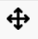 | Move Diagram/Enlargement
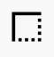 | Modify Diagram Layout

Select & Move
Click the ‘Select & Move ’ button to activate the diagram selection mode. When this mode is active, you can select a diagram for editing. To select a diagram, click inside one of the closed parcels of the diagram. To move the diagram, select and then drag the diagram.

Scale Up / Down
To change the scale of a diagram, select the diagram and then click on the ‘Scale Up / Scale Down ’ buttons.
NOTE: Scales can be changed to only those values compliant with the Survey Practice Handbook published by the Surveyors Registration Board of Victoria.
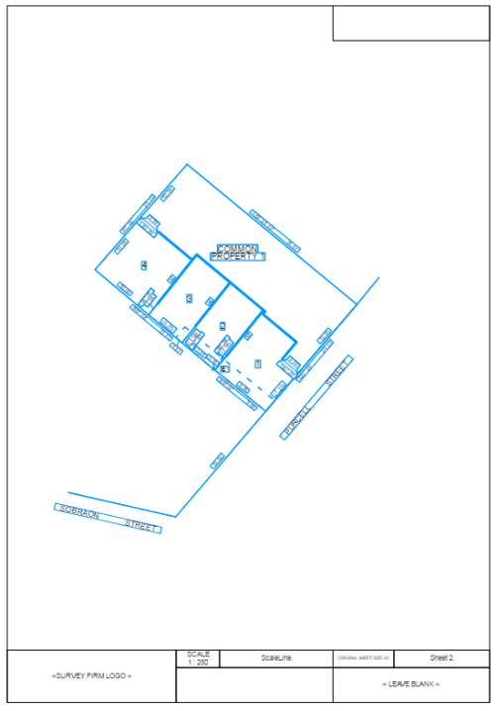
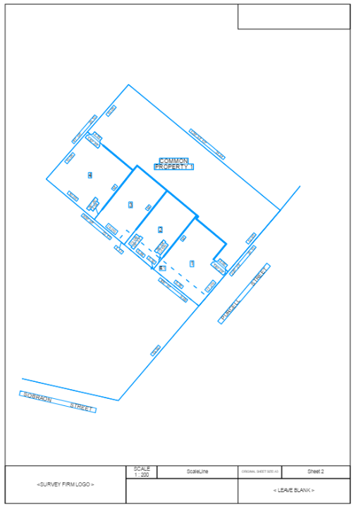
Scale up diagram (1:200)
Scale down diagram (1:250)

Rotate Diagram
To rotate the diagram, click on the ‘Rotate Diagram ’ buttons described previously for labels. The rotation buttons are common between labels and diagrams. When the diagram selection mode is active, clicking the rotation buttons or providing an input will rotate the diagram.
NOTE: If there are any enlargements on the sheet, they will also be rotated.
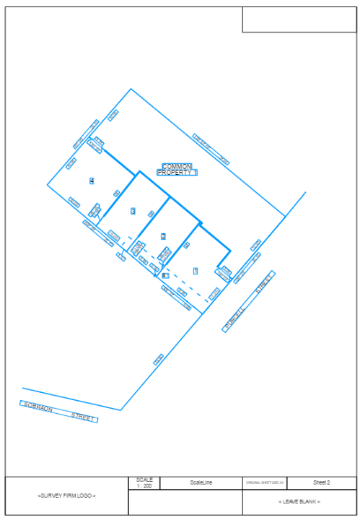
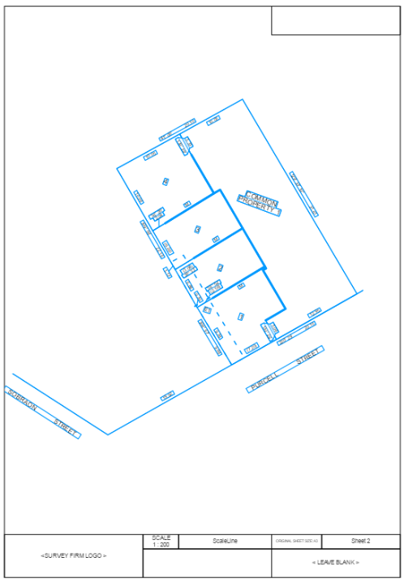
Diagram before rotation
Diagram after rotation

Change Page Layout
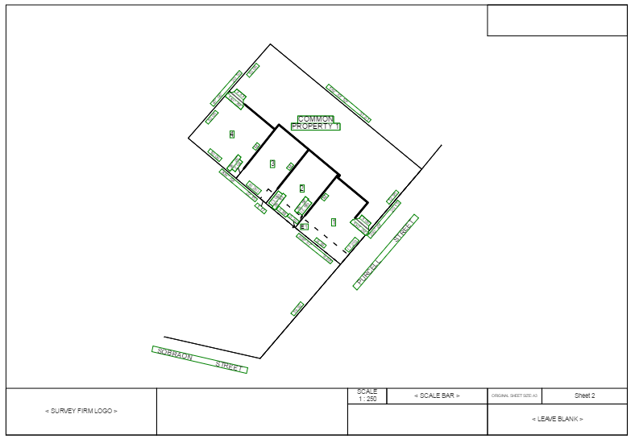
The ‘Change Page Layout ’ button can be used to change the layout of the page between portrait and landscape.
Diagram layout has been changed from portrait to landscape

Move Diagram/Enlargement
To change the placement of the diagram/enlargement within the sheet, click the ‘Move Diagram/Enlargement ’ button, select the diagram/enlargement and drag the mouse.

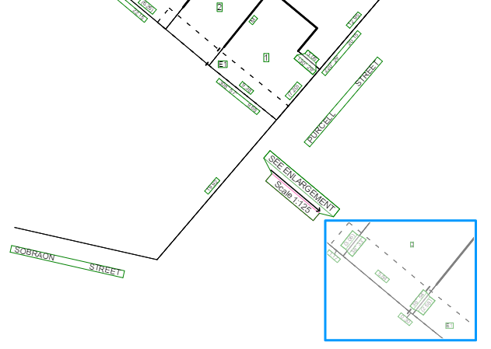
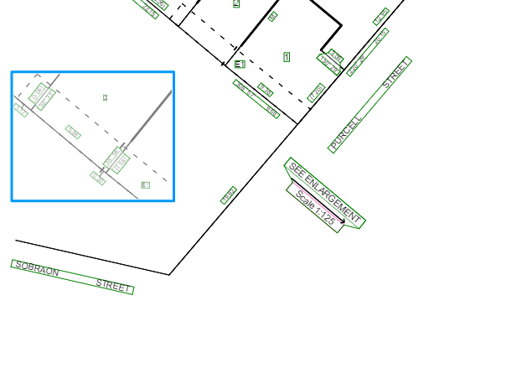
Enlargement diagram before moving
Enlargement diagram after moving

Note: If a diagram/enlargement is moved outside the sheet bounds either partially or fully, the diagram/enlargement will be moved to its original location.

Modify Diagram Layout
To modify the layout of a diagram or an enlargement, click the ‘Modify Diagram Layout ’ button and select the diagram. Modify the layout of the diagram or enlargement by moving, adding and removing vertices.
To move a vertex of the diagram layout, after activating the ‘Modify Diagram Layout ’ button, hover the mouse cursor on the vertex, hold the left click and then move it.

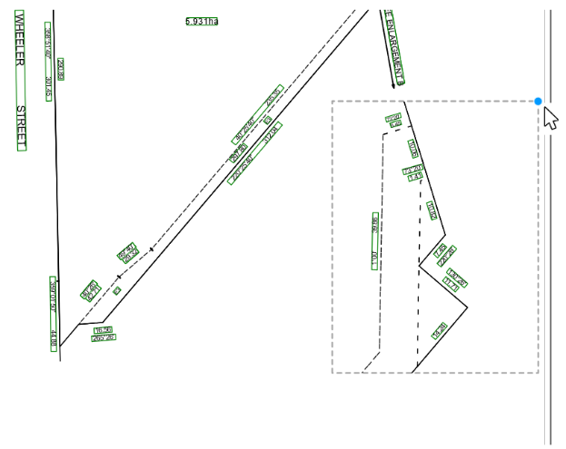
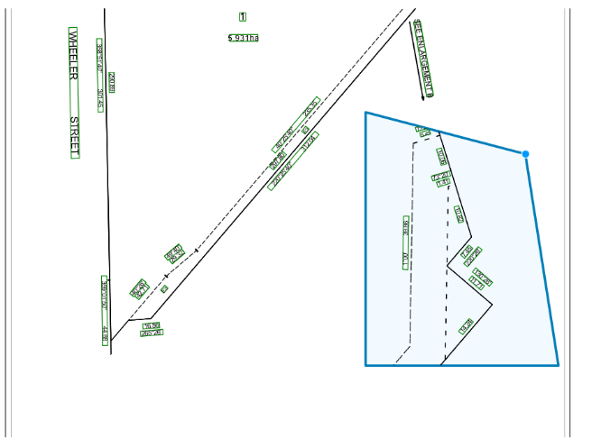
Selecting a vertex for modifying the enlargement diagram layout
Modifying the enlargement diagram layout by moving the vertex

To add a vertex, after activating the ‘Modify Diagram Layout ’ button, hover the mouse cursor on any location in the diagram layout, hold the left click and then move it to create a new vertex.

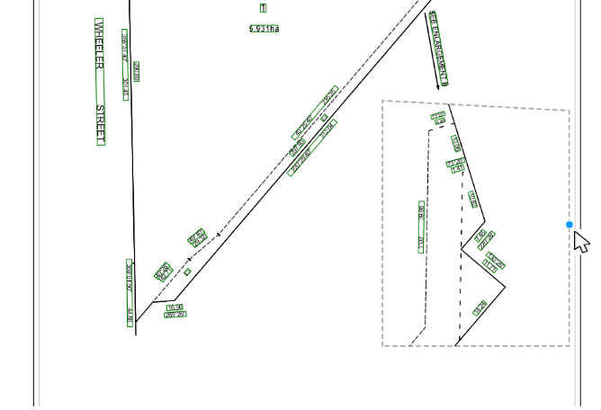
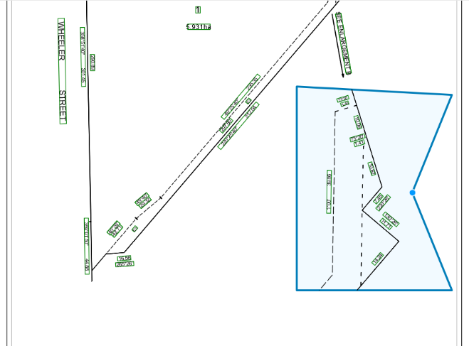
Selecting an arbitrary point to create a new vertex
Modifying the enlargement diagram layout by creating a new vertex

To remove a vertex, after activating the ‘Modify Diagram Layout ’ button, hover the mouse cursor on the vertex, hold Alt key and then left click to remove the vertex.

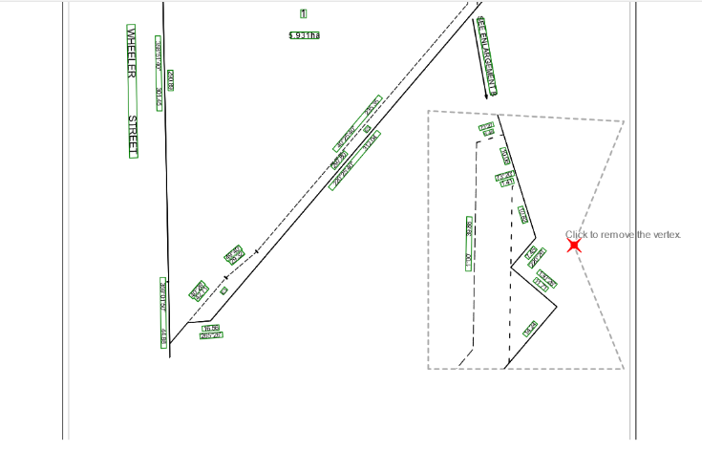
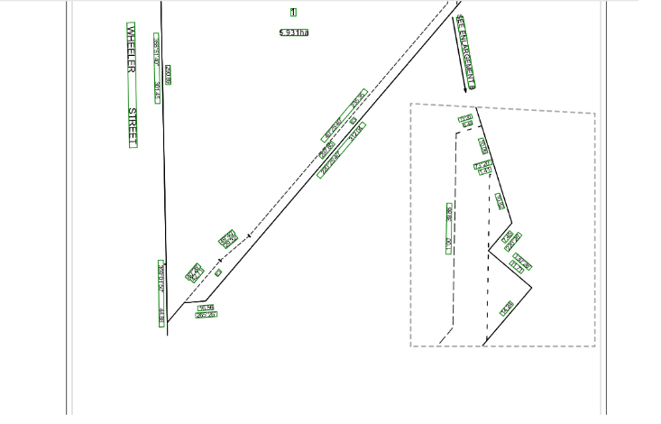
Selecting a vertex to remove from the enlargement diagram layout
The enlargement diagram layout after removing a vertex

Note: When modifying the layout of a diagram or enlargement, if a vertex is moved outside the sheet bounds, the diagram layout will be automatically adjusted that no data is displayed outside the sheet bounds.

57.07. Enlargement Tools
The following functionality is available in the Enlargement Tools section:

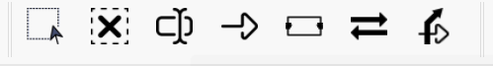
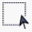 | Create Enlargement
 | Remove Enlargement
 | Change Enlargement ID
 | Create Reference Label
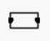 | Create SEE SHEET Label
 | Flip Reference Label’s Arrow
 | Edit Reference Label’s Arrow

Create Enlargement
To create an enlargement, click the ‘Create Enlargement ’ button and draw a box anywhere in the sheet by dragging the mouse. When the dragging action is completed, VET creates an enlargement diagram and by default populates the enlargement with all line work existing in the ePlan data. A ‘Diagram ID’ label is automatically placed at the top of the enlargement.
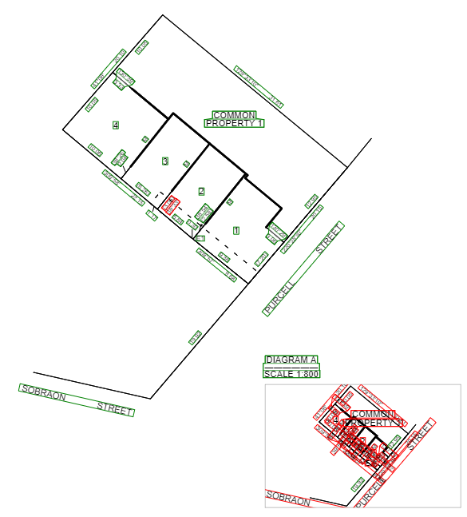
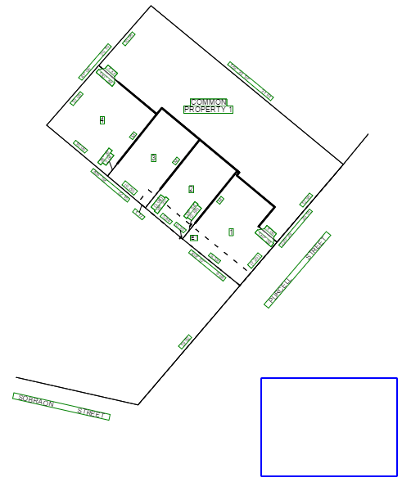

Drag mouse to draw

Line work and ‘See Enlargement’ label added to the sheet
Drawing a box after the ‘Create Enlargement’ button is clicked

The enlargement diagram can now be selected and then scaled up as required to appropriately show the area of interest.

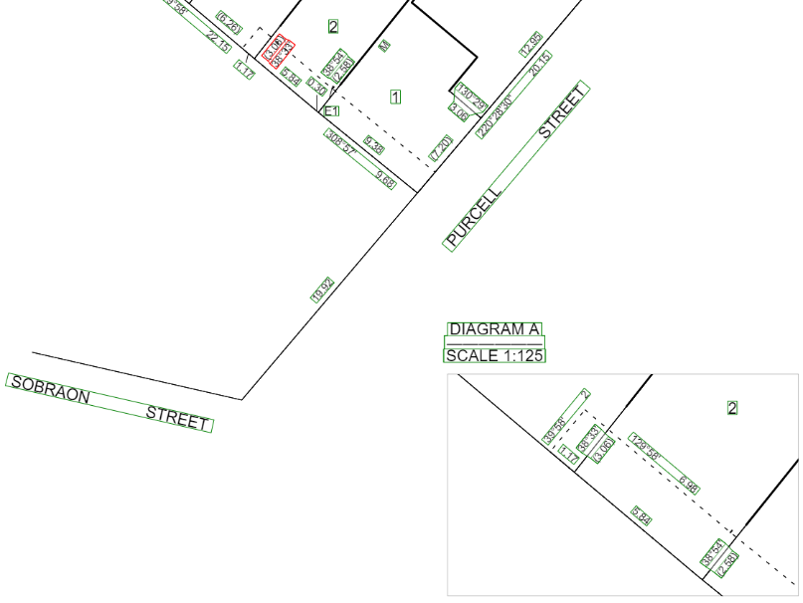
Scaling up the enlargement diagram
Once the area of interest is scaled up, the labels will be placed automatically by the Visualisation Service in their default position. Use the ‘Move Labels Inside Diagram Layout ’ function, to place the labels located outside the diagram layout within the layout. The labels can be adjusted as desired by using the label tools. Once the labels placement is completed, a ‘Reference Label’ can be added and appropriately placed using the related tools.

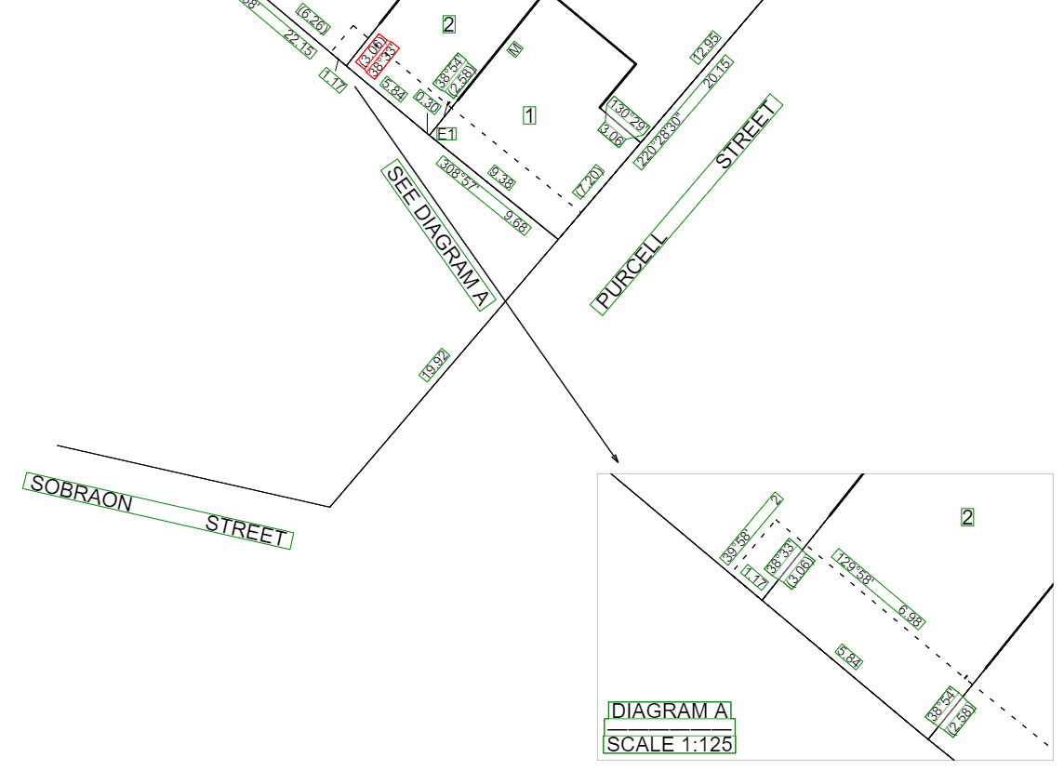
Positioning and rotating the ‘Diagram ID’ and ‘Reference Label’ (SEE DIAGRAM A)

Remove Enlargement
To remove an enlargement, select the enlargement and click the ‘Remove Enlargement ’ button. This action will also remove the associated ‘Diagram ID’ and Reference labels.

Change Enlargement ID
When an enlargement diagram is created, a unique ID will be assigned to the created diagram starting from “A”. This enlargement ID can be changed using this function. The process can be followed using one of the following actions:
- CTRL + click: Click on the enlargement ID label while the CTRL key is pressed.
- Select the label: Select the enlargement ID label and then click on  button.
- Select the diagram: Select the enlargement diagram and then click on button.
When one of these actions is performed, a new dialog box will appear. In this box the desired enlargement ID can be entered, and the enlargement ID will be validated while it is being typed. A descriptive message describes the acceptability of the entered ID.
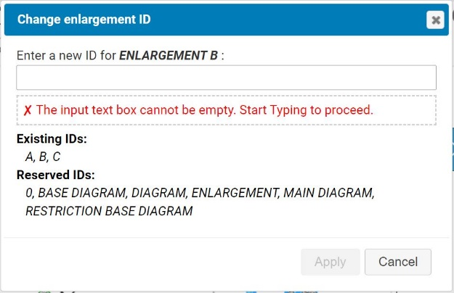
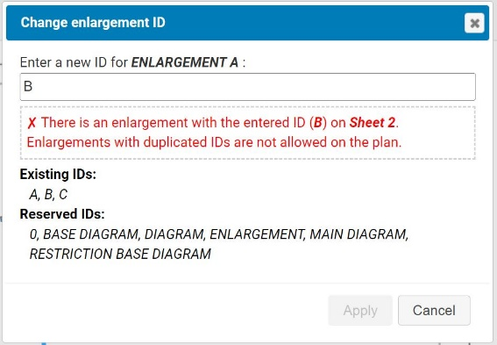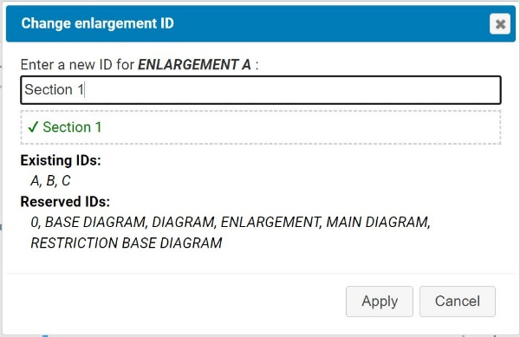
The dialog box for the Change Enlargement ID
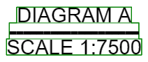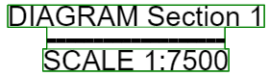
The enlargement ID label before and after changing the enlargement ID

Create Reference Label
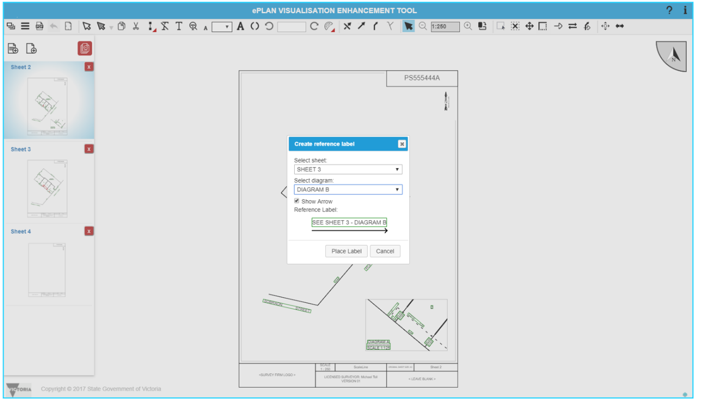
‘Reference Labels’ can be created using this tool. ‘Reference Labels’ are used for referring to other sheets or diagrams in the plan. To add a ‘Reference Label’, click the ‘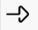’ button. A dialog box will be displayed on the screen to select the desired sheet and diagram, which this label will refer to. The sheets list will contain the existing sheets in the plan and the diagrams list will only show the diagrams on the selected sheet. There is a checkbox to select the display status of the arrow relevant to reference label. A preview of the label will be displayed at the bottom of the dialog box.

When the desired sheet and diagram are selected, press the ‘Place Label’ button, move the mouse curser, and drop the label at the appropriate position. VET will automatically create a ‘Reference Label’ at the selected position. The label and arrow editing tools can be used to modify this label and its related arrow.
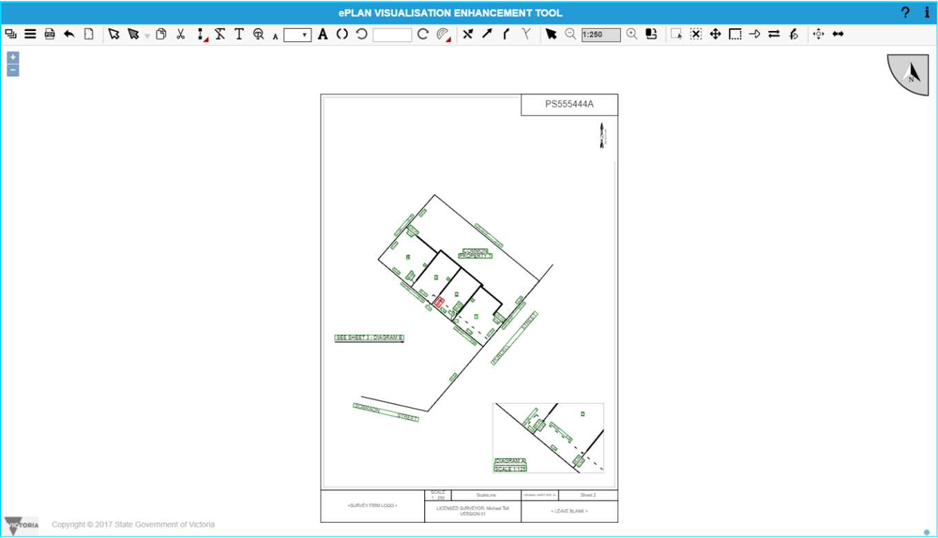
Diagram after ‘Reference Label’ is placed

Create SEE SHEET Label
Using the ‘Create SEE SHEET label ’ button, SEE SHEET labels for the sheets overlapping with the current sheet can be created. The ‘Create SEE SHEET label’ window is shown which includes a list of SEE SHEET labels for the sheets overlapping with current sheet. Click on the desired SEE SHEET label and move the mouse to the position of the label and then click on the desired position.
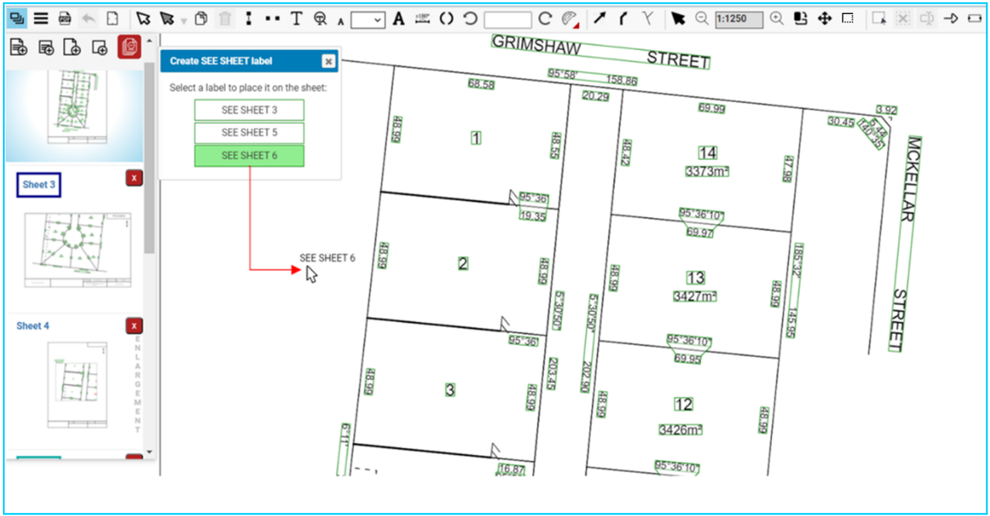

Flip Arrow for a ‘Reference’ Label
Using the ‘Flip Reference Label’s Arrow ’ button, the label arrow’s direction can be reversed.

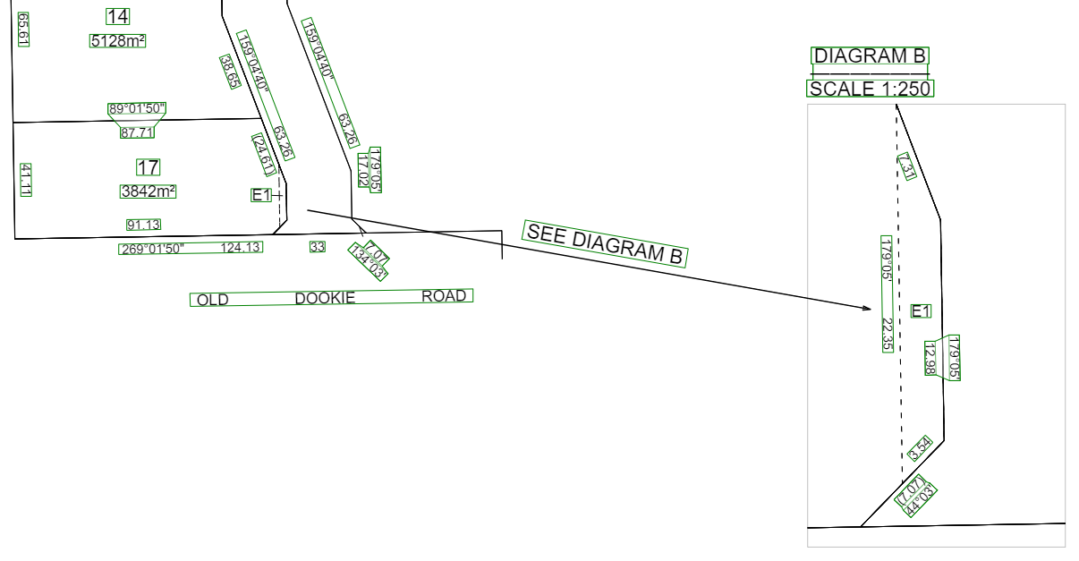
Arrow before flipping

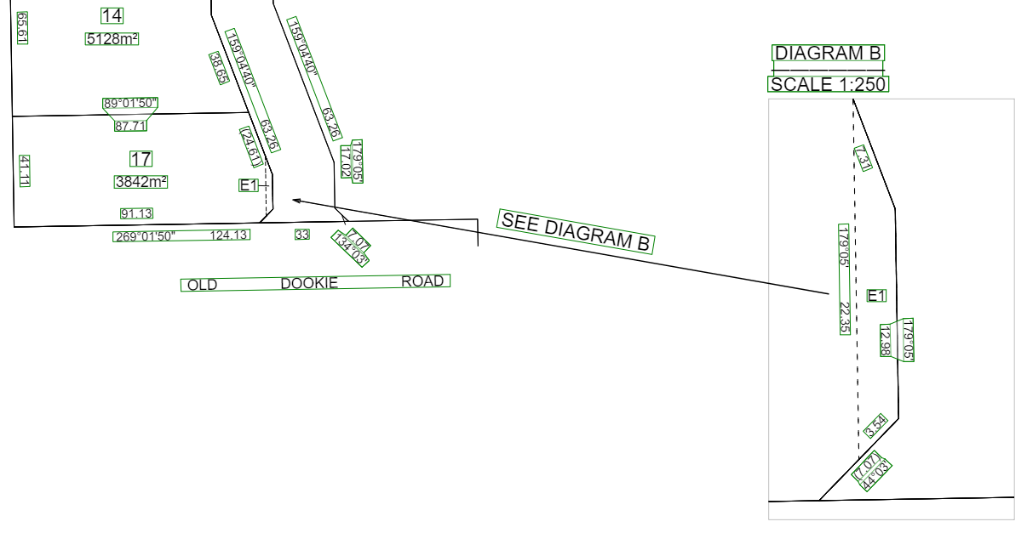
Arrow after flipping

Edit Reference Label’s Arrow
When a ‘Reference Label’ is created, an arrow can be generated as well. This arrow will be placed below the label and the length of the arrow is equal to the length of the label.
Use the ‘Edit Reference Label’s Arrow ’ button to move the position of the arrow relative to a reference label. When the label is selected and the ‘Edit Reference Label’s Arrow’ is active, two small blue circles will appear at the start and end points of the arrow highlighting the editable points. Move the cursor over to one of the highlighted points and drag it. After dragging, the point can be placed at any position in the sheet. While moving, the points will be snapped along the current direction of the arrow which is aligned with its corresponding label.

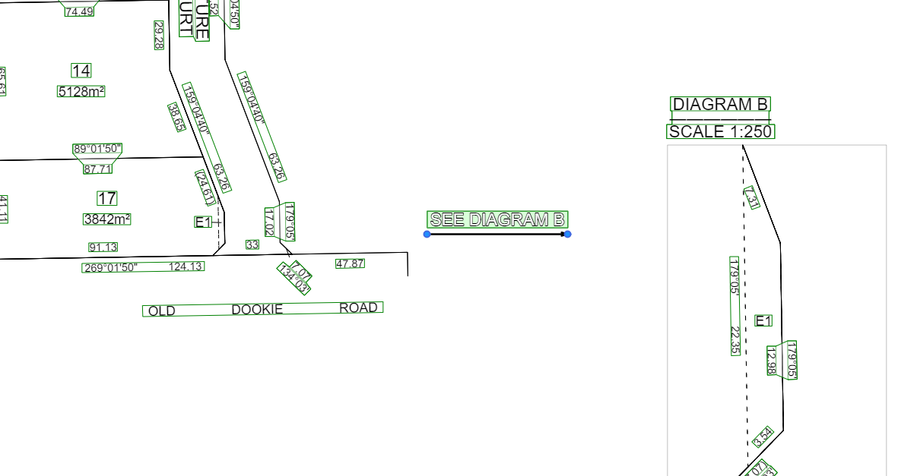
The start and end points of the arrow are highlighted

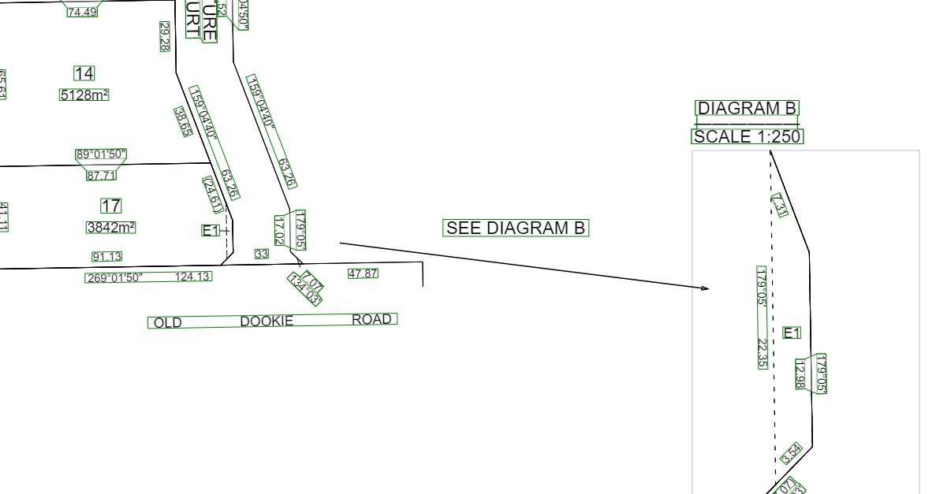
The ‘Reference Label’s Arrow’ after editing

57.08. Exaggeration Tool
Use the ‘Exaggeration Tool ’ to exaggerate any features on the plan. Select the exaggeration tool and then click the line that requires exaggeration. To move the line, drag the end of the line. The feature can be exaggerated by moving one point at a time.

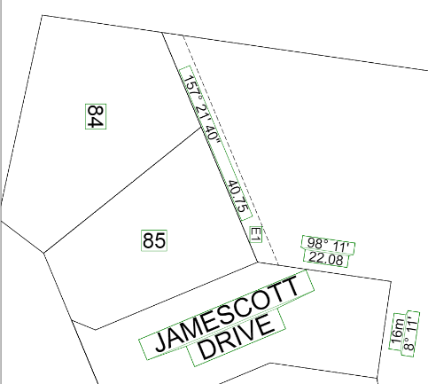
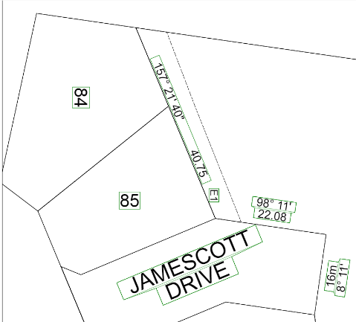
E1 before exaggeration
E1 after exaggeration

When the point is being moved, a pop up will appear next to the pointer showing the displacement of the point in (x,y). These values may be useful to move the other end of the line by the exact value to maintain the parallel bearing of the line regarding other lines.

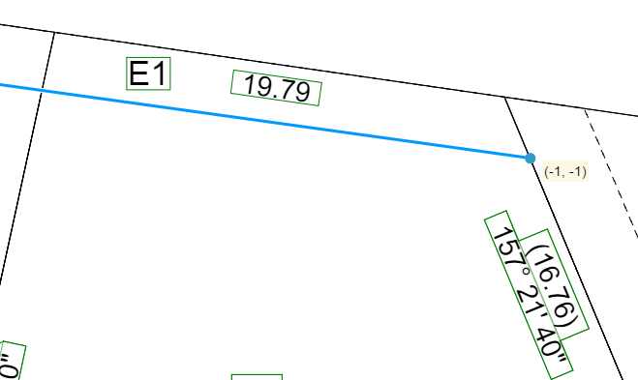
Displacement of the point in (x,y) during exaggeration

57.09. Truncation Tool
The Truncation Tool allows any existing roads to be truncated. To truncate a road, click the tool and select the desired segment of the road. Once the line is highlighted, use the truncation slider to decrease/increase the length of the road.
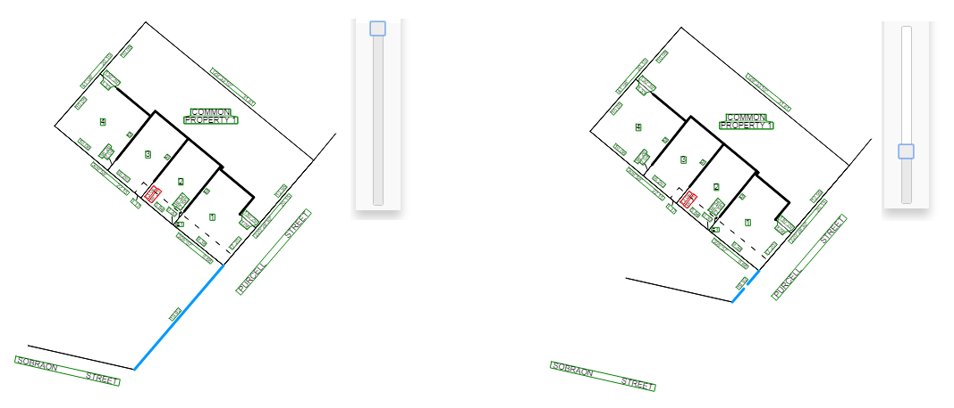
Road after truncation
Road before truncation

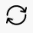
57.10. Building Return Tool
The Building Return Tool allows to reverse hatching of a building return. To reverse a building return hatching direction, click the tool to activate it. Then click on the desired building return to reverse its hatching direction.
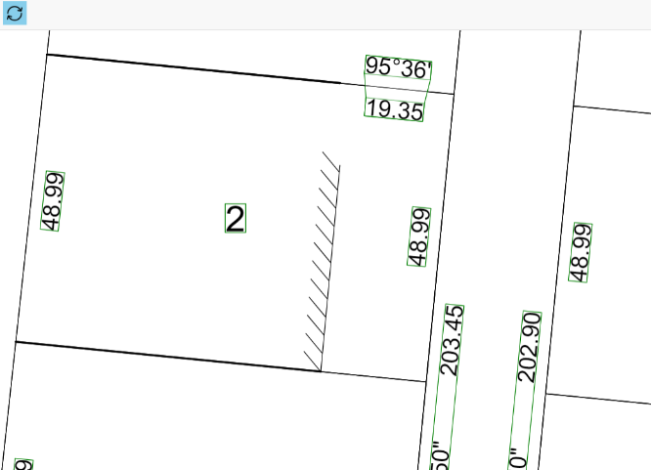
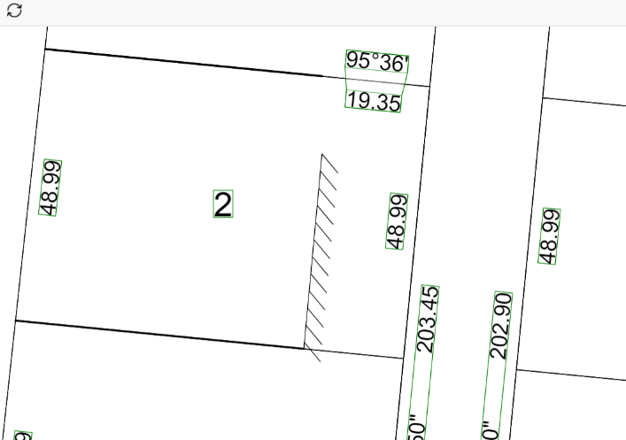
Building return before applying the tool
Building return after applying the tool

57.11. Intelligent Key Sheet (IKS) Tool
The IKS tool is shown in the right-bottom corner of the main display in VET. This section describes the functions of this tool.

Collapse / Expand / Restore Down IKS
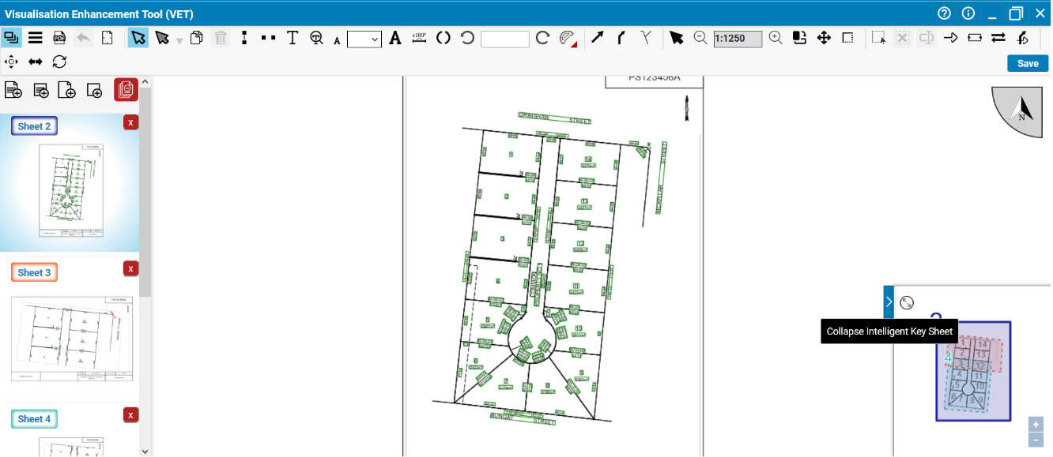
To collapse the IKS tool from the Display Area, click the arrow button next to it.


Click to expand the IKS tool and it will cover the entire Display area.
If the IKS tool is expanded, click again to restore down the IKS tool.
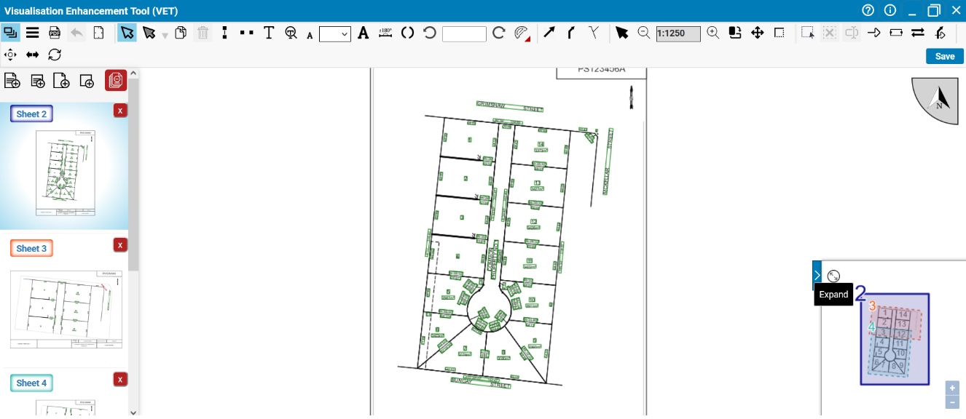

Scale Up / Down Diagram in IKS
Diagrams in all sheets, except the index sheet and Restriction sheets, can be scaled up or down using the IKS tool. To change the scale of a diagram in IKS, select its corresponding sheet and expand the IKS tool and then click on the ‘Scale Up / Scale Down ’ buttons.
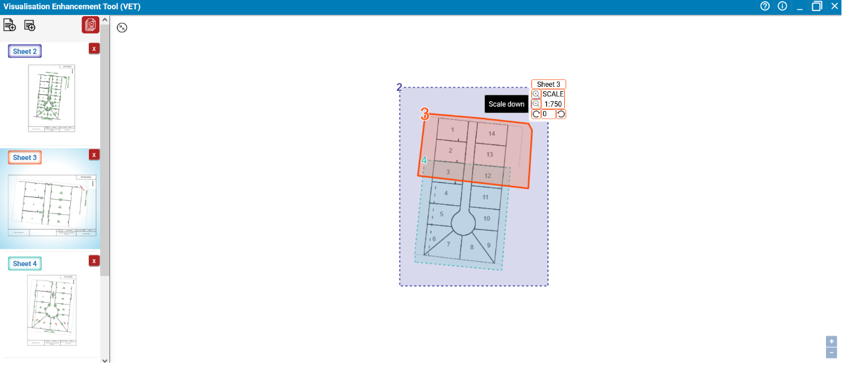

Rotate Diagram in IKS
The diagrams in all sheets, except the index sheet and restriction sheets, can be rotated using the IKS tool. Use the ‘Rotate Counter Clockwise / To a Value / Clockwise ’ functions to rotate a diagram to a different angle. The buttons and will change the angle by 10 degrees. The text box can be used to set the angle of a label to a specific value.
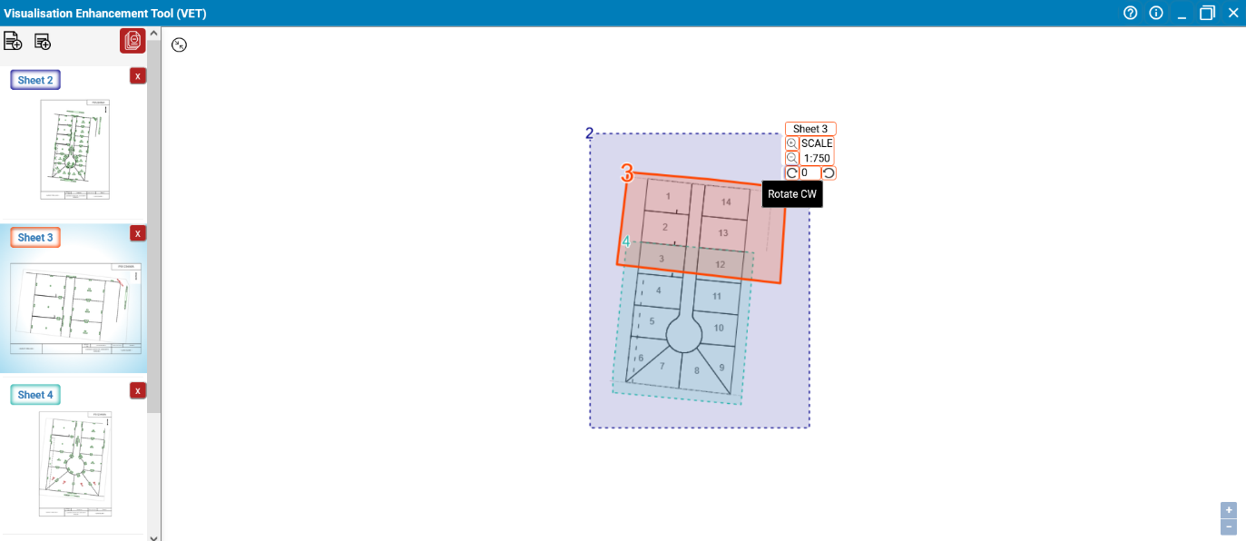

Activate Sheet using IKS
Any sheet with main diagram can be activated using IKS. Double click an inactive sheet within the layout of the diagram in IKS to activate it. Activating sheets in IKS can be done in both Expand and Restore Down views.
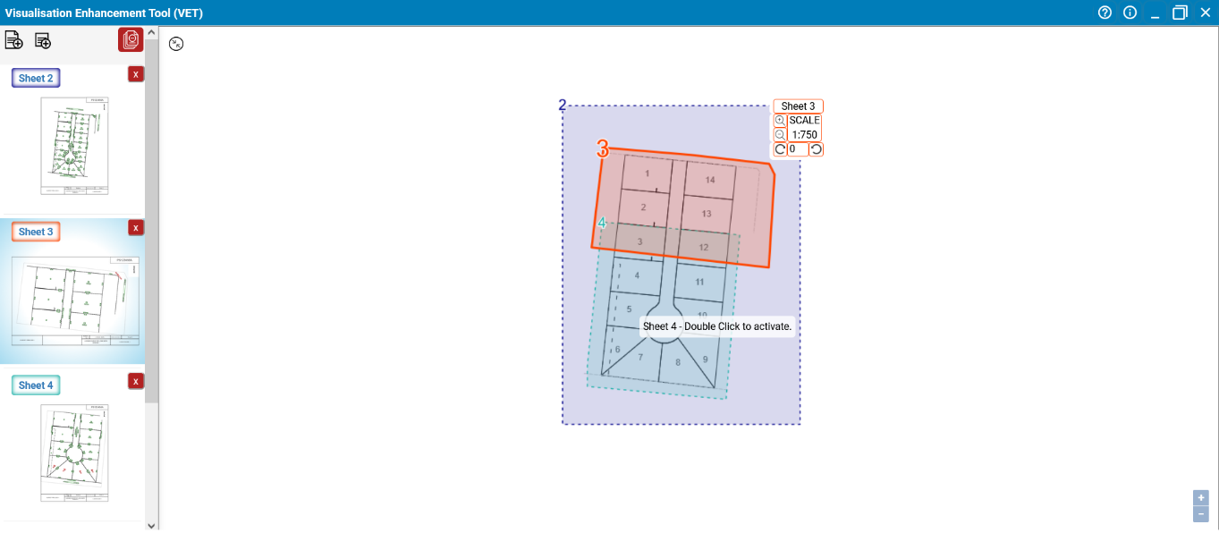

Modify Diagram Layout in IKS
The layout of a diagram can also be modified in IKS by moving, adding and removing vertices.
To move a vertex of the diagram layout in IKS, hover the mouse cursor on the vertex, hold the left click and then move it.
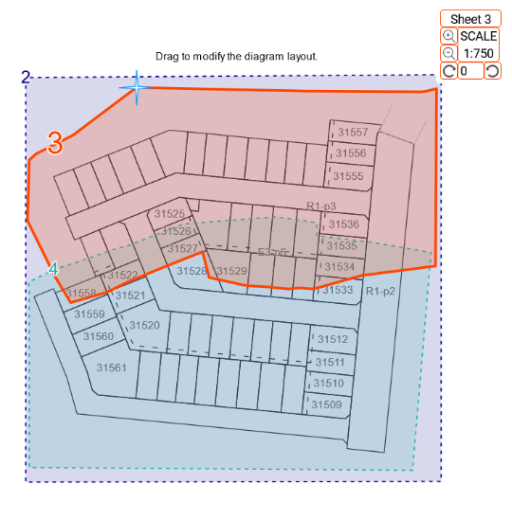
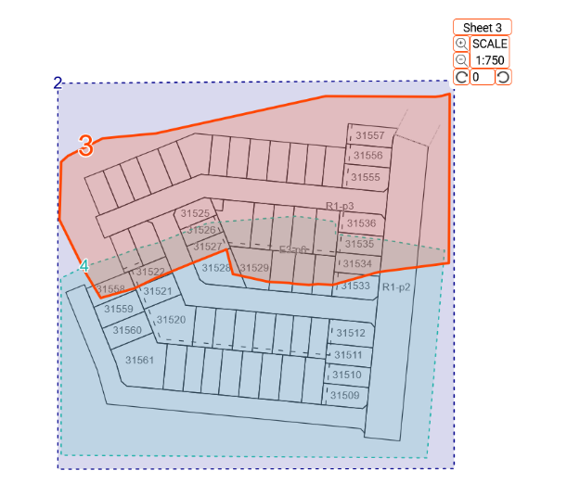
Selecting a vertex for modifying the enlargement diagram layout
Modifying the diagram layout by moving the vertex

To add a vertex in IKS, hover the mouse cursor on any location in the diagram layout, hold the left click and then move it to create a new vertex.
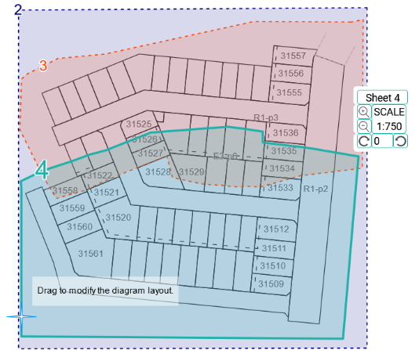
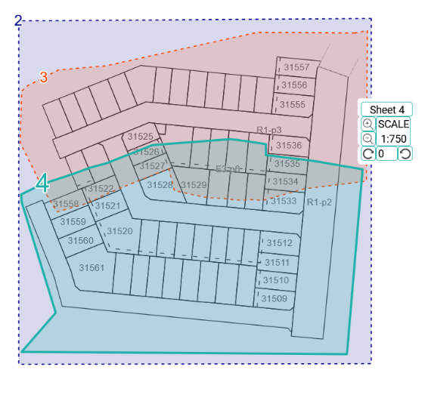
Selecting an arbitrary point in IKS to create a new vertex
Modifying the diagram layout in IKS by creating a new vertex

To remove a vertex in IKS, hover the mouse cursor on the vertex, hold Alt key and then left click to remove the vertex.
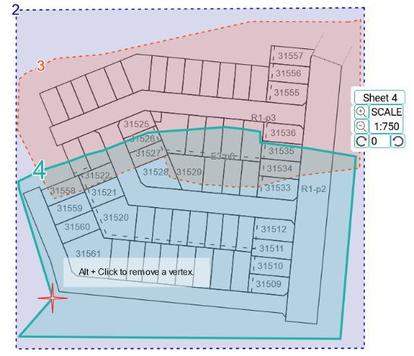
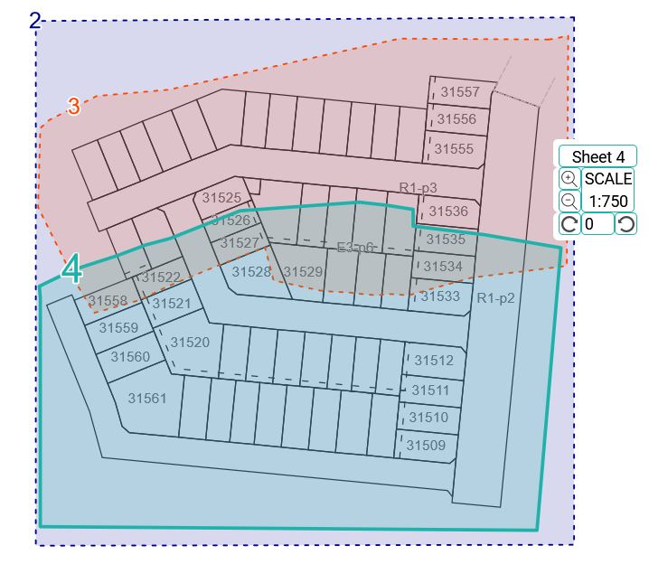
Selecting a vertex to remove from the diagram layout in IKS
The diagram layout after removing a vertex in IKS

Note: When modifying the layout of a diagram in IKS, if a vertex is moved outside the sheet bounds, the diagram layout will be automatically adjusted that no data is displayed outside the sheet bounds.
Note: Any modification applied to layout and scale of a diagram in IKS is reflected in its corresponding sheet and vice versa.

Need more information?
Further information on this topic can be found by:
- Visiting the SPEAR website www.spear.land.vic.gov.au/SPEAR.
- Contacting the SPEAR Service Desk on 9194 0612 or email spear.info@delwp.vic.gov.au

