User Guide 23 Local Administrator
Purpose of this User Guide
The purpose of this User Guide is to provide information on how to access and use the Local Administrator functions available within SPEAR. The screens and fields that are described herein may have online help / tips when the mouse cursor is floated over the field. Errors or omissions in data supplied will be highlighted with red-inline errors, prompting the user to correct or supply the missing information. Specific questions about Local Administrator functionality relevant to your organisation should be directed to the SPEAR Service Desk.
Who should read this guide?
Primary audience: Local Administrators
For information: Other SPEAR users
Introduction
Each organisation in SPEAR can have one or more Local Administrators. The role of a Local Administrator is to manage users and sites within their organisation.
23.1 How do I access the Administration Menu?
Users in SPEAR may have multiple roles. Stand-alone administrators will see the Administration Menu when they login to SPEAR.
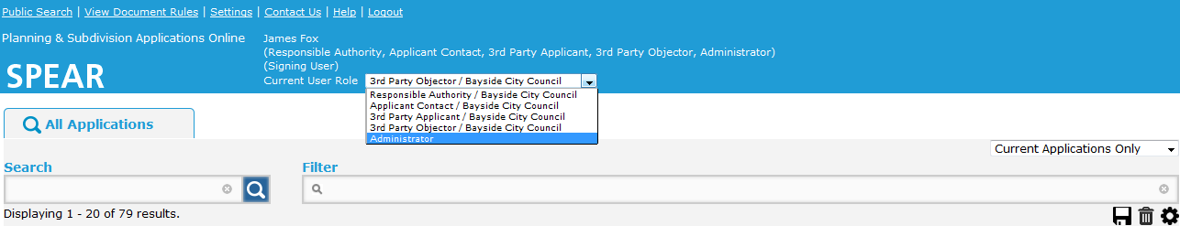
Users with additional roles can access the Administration Menu by changing their Current User Role to ‘Administrator’ from the drop-down box located on the Application List screen.

The options available on the Administration Menu may vary depending on your organisation type.
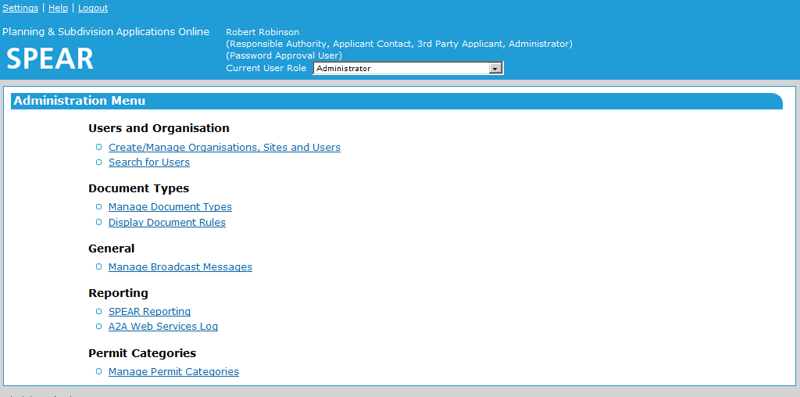

23.2 How do I edit my organisation details?
From the Administration Menu click the Create/Manage Organisations, Sites and Users link. If your organisation has multiple sites or offices in SPEAR, you can select the site you wish to manage. Click ‘edit’ to proceed to the Edit Organisation/Site screen.
From here you can edit the address, phone number and other contact details of your organisation. You can also change the email address for SPEAR email notifications and add your organisation logo.
Responsible Authority Local Administrators can also manage their list of referral authorities, enable applicant proposed street addresses and add standard conditions for use with the ‘Manage Conditions’ functionality.
See Section 23.7 for specific information on Responsible Authorities Local Administrators managing which referral authorities they can refer to, and whether referrals to internal referral authorities are statutory or not.
Any changes to the organisation details must be authenticated with your SPEAR password.
23.3 How do I create a new user?
To add a new user, click the Create/Manage Organisations, Sites and Users link from the Administration Menu. Click ‘display users’ to proceed to a list of all the active users in your organisation.
Click ‘create new user’ where you will need to provide the name and contact details of the new user. You will also be required to select one or more roles or sites for the user and select the level of authentication required in SPEAR. For more information, see User Guide 42 – User Authentication Levels & Document Authentication in SPEAR.
When creating a new user, SPEAR will prompt you to authenticate using your SPEAR password. SPEAR will then send the new user an email with their username and a link to create a preferred password for the account.
NOTE: Applicant Local Administrators will need to ensure they enter the Surveyors Registration Number for licensed surveyors. If the user will be primarily submitting subdivision applications, the ‘Prefer to process Subdivision Applications?’ should be ticked.
Responsible Authority Local Administrators can indicate whether the user is a delegated planning officer and create access limited users. For more information, see User Guide 44 - Performing Internal Requests.
23.4 How do I edit an existing user, including forgotten password?
To edit an existing user, click the Create/Manage Organisations, Sites and Users link from the Administration Menu. Click ‘display users’ to proceed to a list of all the active users in your organisation.
Alternatively, you can click the Search for Users link from the Administration Menu and search for a user.
Once you have found the user you wish to edit, click the associated User ID to proceed to the Edit user screen. You can make any required changes to the user details or password before submitting and authenticating the changes with your SPEAR password.
NOTE: If you have changed/reset the user’s password, you will need to provide the new temporary password to them, advising they have 3 days to change before it inactivates.
If a user has left your organisation, you can edit their profile and select ’Permanently Inactive’ from the status drop-down box.
23.5 How do I create standard conditions for use with ‘Manage Conditions’?
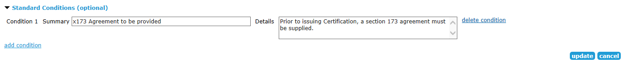
The ‘Manage Conditions’ function allows Responsible Authorities to list conditions that must be met prior to certification and/or SOC and tick them off as they are met. Responsible Authority Local Administrators can create a list of standard conditions to streamline the process.
To create a new standard condition, click the Create/Manage Organisations, Sites and Users link from the Administration Menu, select the Responsible Authority name and click ‘edit’ .
To add a condition, select the add condition link. You will be prompted to enter a brief summary of each condition and further information may be provided in the Details field.
Once the standard conditions have been updated, select ‘Update’ and authenticate the changes with your SPEAR password.
The standard conditions will now be available for selection on the Manage Conditions screen. For more information about managing conditions, see SPEAR User Guide 29 – Manage Conditions.
23.6 How do I create an additional site?
For Responsible Authority Local Administrators, adding a new site will create an internal referral authority. Local Administrators should remember to add any internal referral authorities that they create to their list (that they refer to). The list can be accessed from the Edit Organisation/Site screen for the main responsible authority organisation.
For applicant and referral authority Local Administrators, creating a site will allow you to set up an additional office or location in SPEAR. Users can belong to one or multiple sites, and each site can have a different email address for notifications.
To create a new site, click the Create/Manage Organisations, Sites and Users link from the Administration Menu and click ‘Create Site’.
You will need to provide a name for the site, as well as contact details including street or postal address and the email address for SPEAR email notifications.
A logo can also be assigned to a secondary site profile. This logo is applied to both SPEAR generated letterhead and plans (ePlan and OC schedules) supplied by that site, independently of the logo which has been assigned to the primary site (head office). Where a site logo has not been supplied, then the primary site logo will be used.
Once the site has been added, you are able to create users and assign them to the site via the ‘roles’ section of the new user form. Existing users can be edited to provide access to the new site if required.
23.7 How do I manage which referral authorities we can refer to?
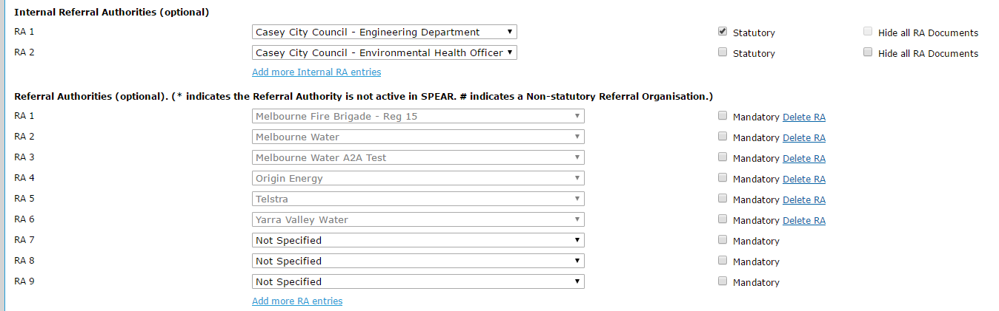
When editing an organisation, Responsible Authority Local Administrators can create a list of internal and external referral authorities. The organisations listed will be available to be referred to within their SPEAR applications.

- Use the drop-down lists to select which internal departments or external authorities you wish to add. See Section 23.6 to create additional sites (internal referral authorities). They will not appear in this list unless the site has been created first.
- Use the Add more RA entries’/ Add more Internal RA entries links to add additional rows if you require more entries.
- Use the ‘Statutory’ checkbox to specify if an internal referral authority is to receive statutory referrals.
- Use the ‘Hide all RA Documents’ checkbox to keep all documents supplied by the internal referral authority hidden from external organisations. Their high-level response to the referral (Consent, Object, etc) will be the only thing shown.
- Selecting the ‘Mandatory’ checkbox next to a referral authority name will ensure that when a Responsible Authority user is performing a referral request, the selection will default to the maximum referral (Sec 55 and/or 8 depending on the application type). Referral authorities not listed as mandatory will default to 'Don't refer'.
- Use the Delete RA link to remove that entry from the list – the RA listed will no longer be available to be referred to in your organisation’s SPEAR applications.
23.8 How do I add a surcharge to fee payments made through SPEAR?
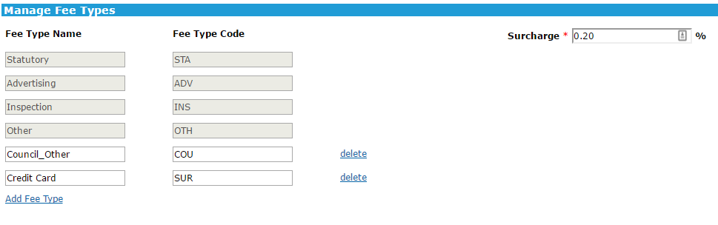
To set a surcharge percentage for card payments through SPEAR, go to the Manage Fee Types page. Modify the ‘Surcharge’ field to the desired percentage value, then click ‘save and close’.
After this has been completed, when a user attempts to pay a fee to the Responsible Authority they will be shown the surcharge amount on the Payment screen and the adjusted amount to pay.
23.9 How do I manage the custom fee types for payments made through SPEAR?
The Manage Fee Types screen allows Responsible Authority Local Administrators to add, edit and delete custom fee types.
As shown in the screenshot in section 23.8, there are several default fee type names and fee type codes, as well as the facility to add additional rows of custom fee types.
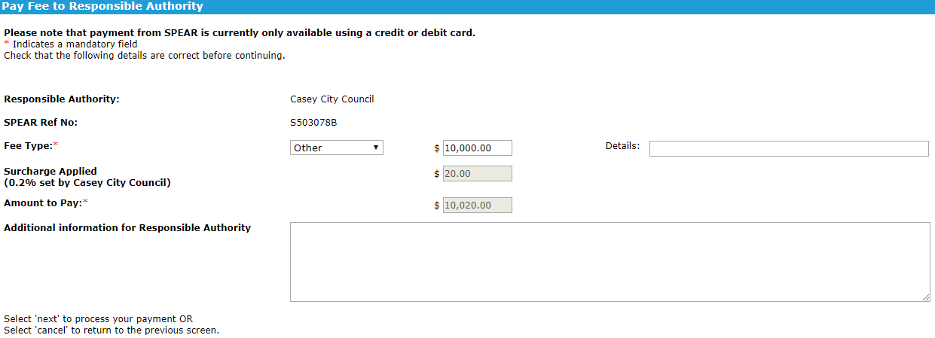
Use the Add Fee Type link to add an extra row where you can specify a new fee type name and assign a unique code. The fee type name will be displayed to the user when they are selecting what type of fee to pay and will also be used to identify the payment type in the Online Payments SPEAR report.

The fee type code will be added to the payment reference code which can be used to easily identify the payment type in your bank statement. Clicking ‘save and close’ will save the new fee type into the system and will be available for use immediately by anyone using SPEAR payments.
Custom fee types can be modified by changing the values in the editable text boxes then clicking ‘save and close’ or can be deleted by clicking the delete link, then clicking ‘save and close’.
NOTE: Default fee types cannot be modified or deleted.
23.10 Can I edit/create new document types?
The Manage Document Types screen allows Responsible Authority Local Administrators to edit / customise some of the properties of some documents in SPEAR.
NOTE: This functionality is to be used cautiously as the SPEAR Service Desk does not have access to these local documents. This severely restricts the level of assistance able to be provided.
Please contact the SPEAR Service Desk on 9194 0612 before making any changes to the documents listed on this screen.
23.11 How to control what document types are available to the public during the advertising period
SPEAR gives Local Administrators the ability to control which documents are available on the Summary screen. This will impact what documents the public are able to view from the Summary screen if an application has been advertised.
Each document type in SPEAR can be modified from the ‘Manage Document Types’ menu. The following two options are available to customise the availability of documents from the Summary screen:
- Show in Summary tab:
Allow a document to be accessed from the Summary screen of an application. This setting applies to all registered users in SPEAR, who are a party to the application. This setting does not impact what the public can view.
- Show in Summary tab (Public):
  - Yes: Document will always be visible, even if the application is not advertised
  - Yes, only during advertising: Will be visible to the public but only while the permit is being advertised and until the permit decision has been made
  - No: Document is always hidden from the public, even during advertising
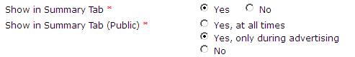
23.12 Can I send a broadcast message to users within my organisation?
Local Administrators can create a broadcast message that is viewable by users within their organisation upon login to SPEAR.
Click on the Manage Broadcast Messages link from the Administration Menu, you can either edit an existing entry or create a new broadcast message by clicking ‘add new’.
Each message needs to include a heading and should have a start and end date/time supplied. You can also attach a PDF document for users to download from the broadcast message.
23.13 How do I run reports from SPEAR?
By default, only Local Administrators can run reports in SPEAR by selecting ‘SPEAR Reporting’ from the Administration Menu. However, if they choose, Local Administrators can enable all users within their organisation to access and run reports.
To do this, edit your organisation’s details (see 23.2 above) and tick the box stating, ‘Allow SPEAR Reports to be viewed by all users?’ before confirming the changes.
Users will then be able to access the reports via the menu at the top of the SPEAR screen. For more information, see User Guide 54 – SPEAR Reporting.
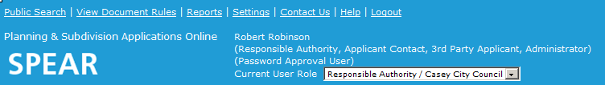

23.14 How do I edit the format for notifications within my organisation?
Local Administrators can choose between receiving notifications in HTML formatted text (default setting) and/or plain text format within their organisation.
From the Administration Menu, click the Create/Manage Organisations, Sites and Users link. If your organisation has multiple sites or offices in SPEAR, you will need to select the main site. Click ‘edit’ to proceed to the Edit Organisation/Site screen.
From here you can edit the ‘Preferred format for Notifications’.
Need more information?
Further information on this topic can be found by:
- Visiting the SPEAR website www.spear.land.vic.gov.au/SPEAR.
- Contacting the SPEAR Service Desk on 9194 0612 or email spear.info@delwp.vic.gov.au

